JavaScript is the programming language of HTML and the Web.

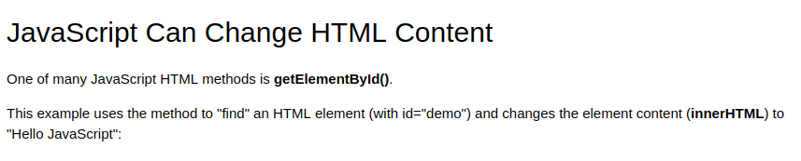

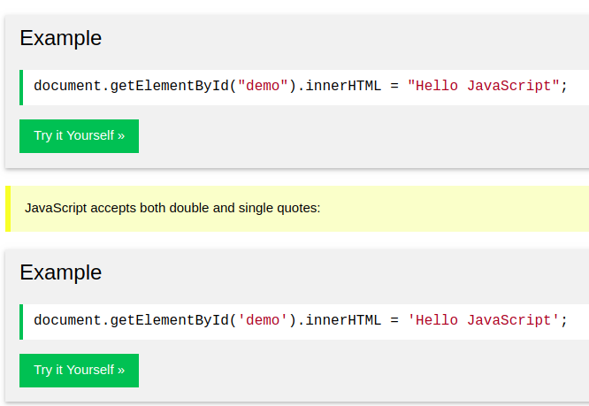

**Nice Example**

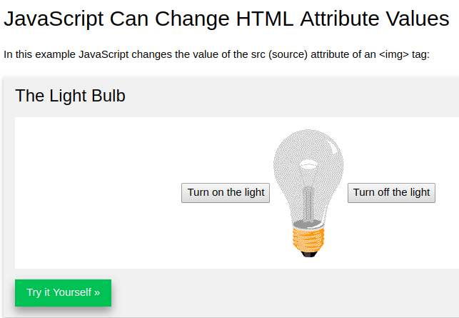

<https://www.w3schools.com/js/tryit.asp?filename=tryjs_intro_lightbulb>

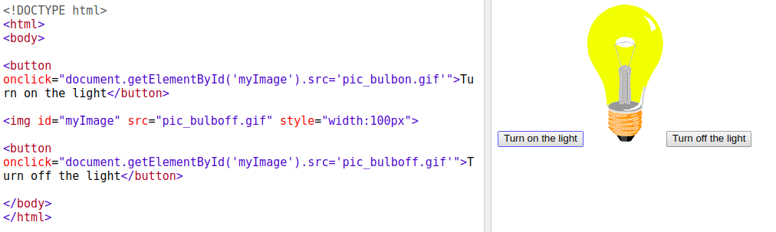

**JS css Example**

## JavaScript Can Hide HTML Elements

<https://www.w3schools.com/js/tryit.asp?filen>

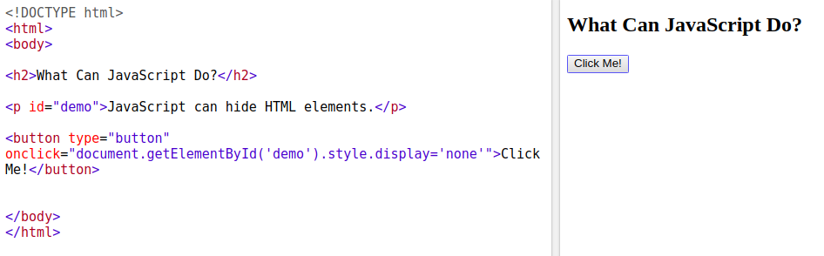

## JavaScript in <head> or <body>

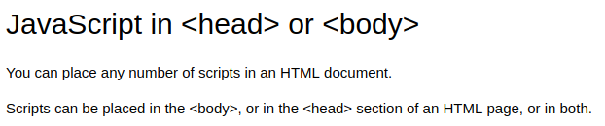



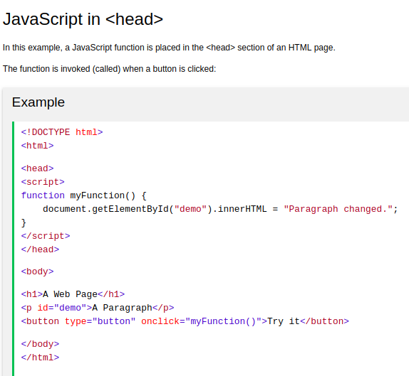

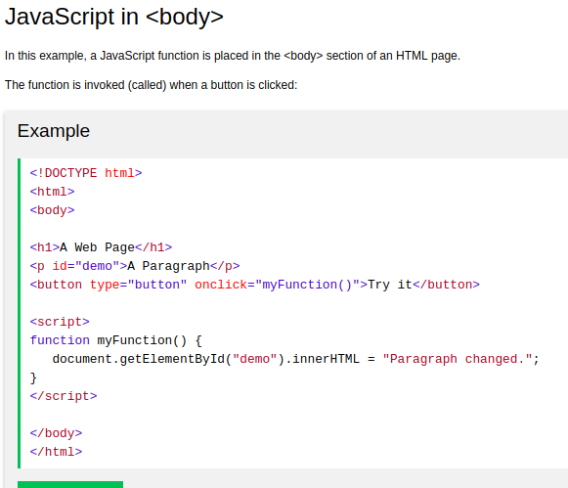

## External JavaScript

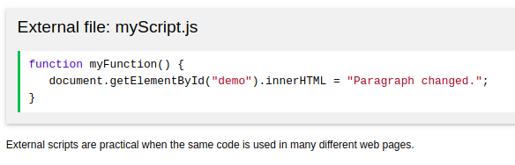

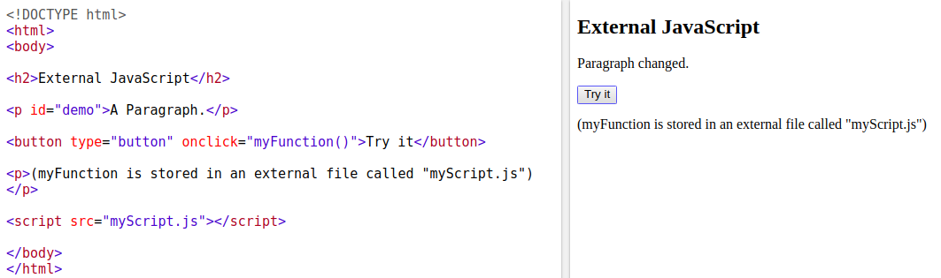

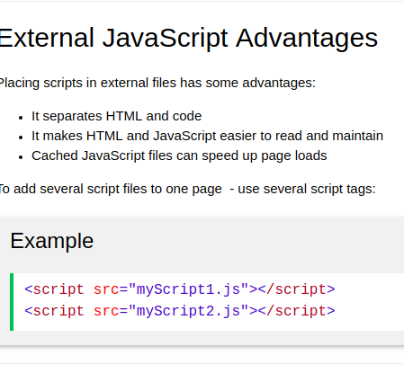

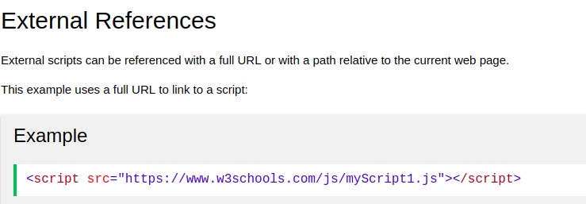

**What is Hoisting in JavaScript ? Most important question in JS developer interview**

In JavaScript, a variable can be used before it has been declared يعلن - يعرف .

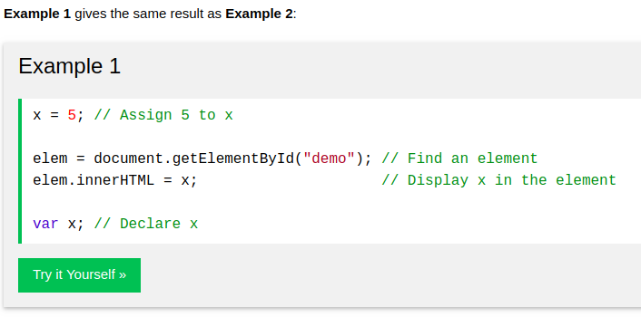



Hoisting is JavaScript's default behavior of moving all declarations to the top of the current scope (to the top of the current script or the current function).

**The math operations with Converting the ‘string’**

the + operation converts (the number when adding to string ‘’) to string.

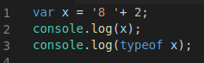

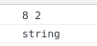

Important Note 1:

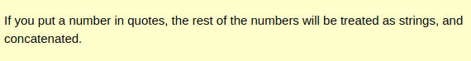

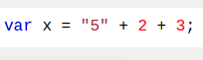

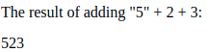

Important Note 2:

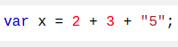

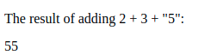

-----------------

the - * / % operations convert (the string ‘’ when adding to number) to number.

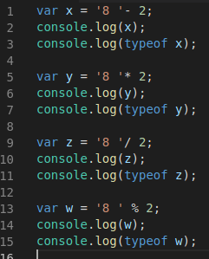

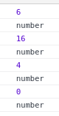

**JS HTML DOM addEventListener()**

-The addEventListener() method attaches an event handler to the specified element. تقوم بإرفاق معالج أحداث بالعنصر المحدد.

- element.addEventListener(event, function, useCapture)

- event : Required. A String that specifies the name of the event.

events: https://www.w3schools.com/jsref/dom_obj_event.asp

- function: Required. Specifies the function to run when the event occurs.

- document.getElementById("id").addEventListener("click", function(){});

- **Tip:** Use the [removeEventListener()](https://www.w3schools.com/jsref/met_element_removeeventlistener.asp) method to remove an event handler that has been attached with the addEventListener() method.

**-Tip:** Use the [document.addEventListener()](https://www.w3schools.com/jsref/met_document_addeventlistener.asp) method to attach an event handler to the document.

Ex:

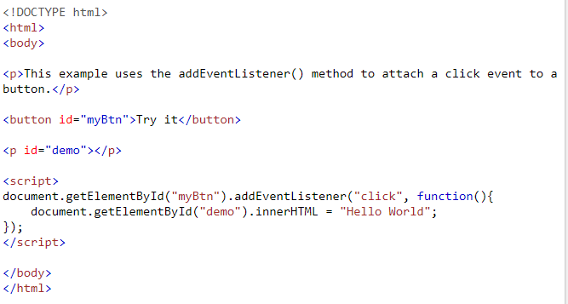

In Browser

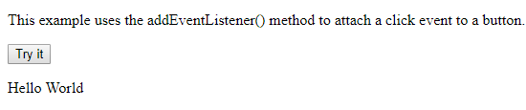

**Logical operation ! && ||**

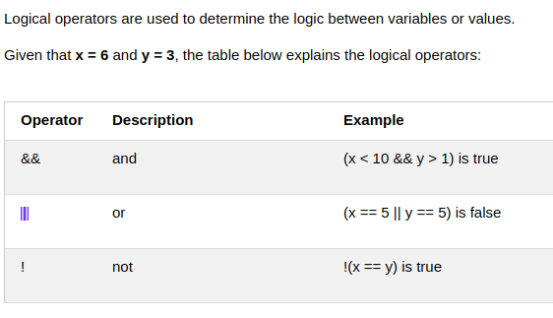

who execute first :

1  **not !**

2  **and &&**

3  **or ||**

## Conditional (Ternary ثلاثي) Operator

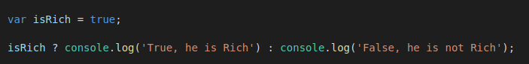

That means :

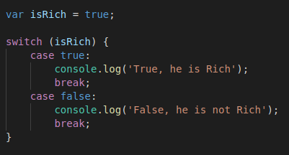

# Switch Statement

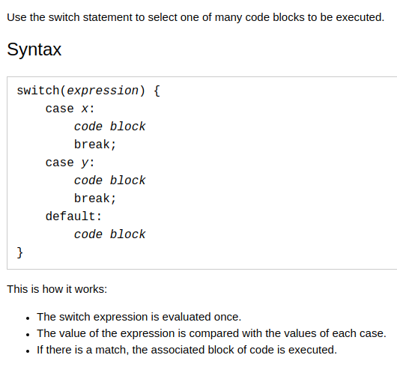

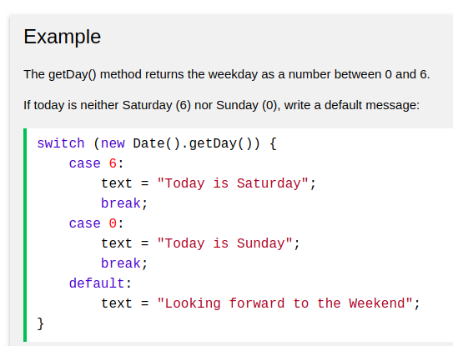

# Operator precedence - order

The following table is ordered from highe[W](https://developer.mozilla.org/en-US/docs/Web/JavaScript/Reference/Operators/Operator_Precedence)st (20) to lowest (1) precedence.

[https://developer.mozilla.org/en-US/docs/eb/JavaScript/Reference/Operators/Operator_Precedence](https://developer.mozilla.org/en-US/docs/Web/JavaScript/Reference/Operators/Operator_Precedence)

**logical for numbers and string**

0 zero as logic is false

all numbers else zero as logic is true

‘ ‘ as logic is false

‘ncjdncjdnccdkl’ as logic is true

empty array as logic is false

**To insert variables inside string**

use ` `

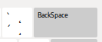

not ‘ ‘

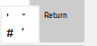

ex:



## The else if Statement ( note : and the another down if will not be executed ) that means only one if will be executed

**if** (*condition1*) {  
    block of code to be executed if condition1 is true **and the another down will not be executed**  
}

**else if** (*condition2*) {  
    block of code to be executed if the condition1 is false and condition2 is true **and the another down will not be executed**  
}

**else** {  
    block of code to be executed if the condition1 is false and condition2 is false  
}

## JavaScript Display Possibilities

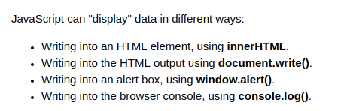

## Using innerHTML

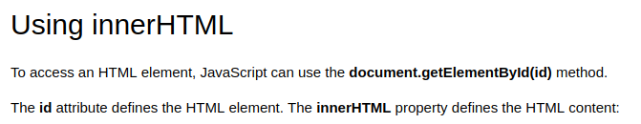

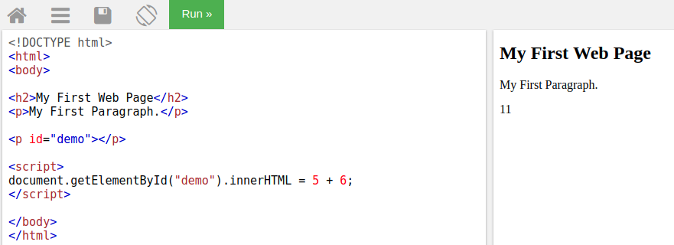

## Using document.write()



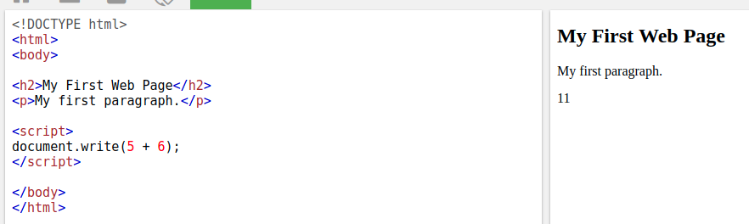



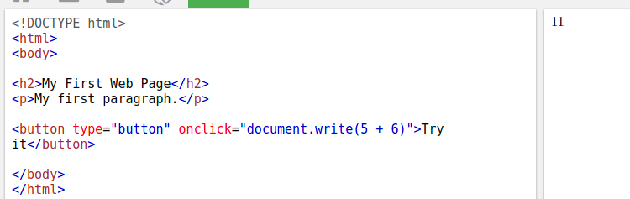

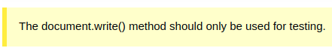

## Using window.alert()

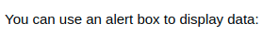

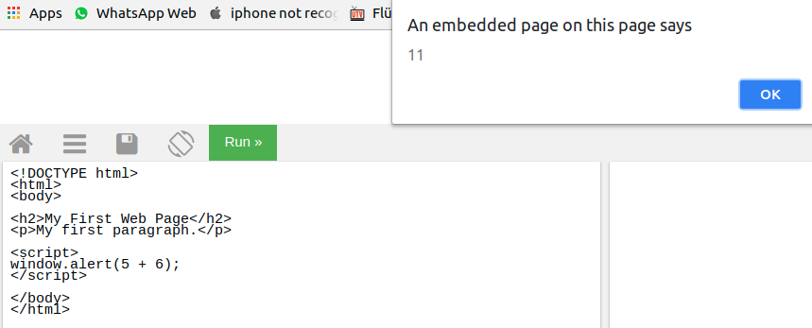

## Using console.log()

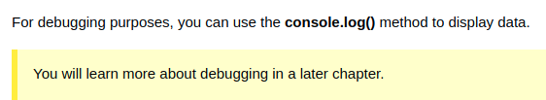

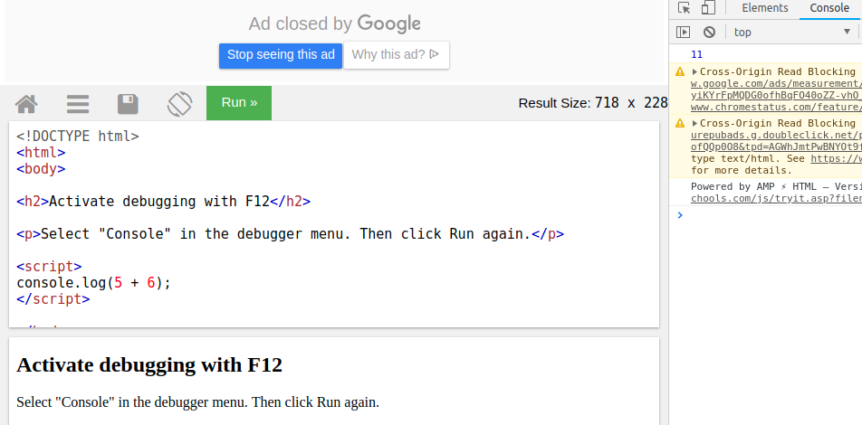

# JavaScript Statements

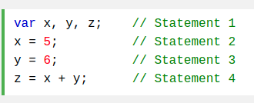

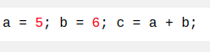

## JavaScript White Space

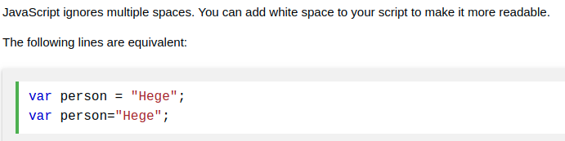

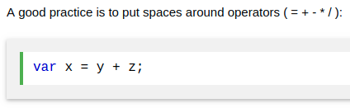

## JavaScript Line Length and Line Breaks

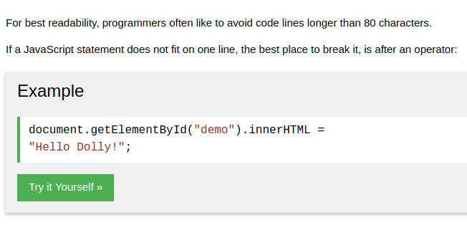

**Variable = Variable + ‘ Hallo ‘**

Variable += ‘ Hallo ‘ ;

**Classy if – one line**

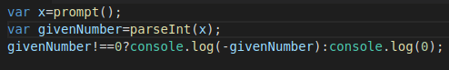

var x=prompt();

var givenNumber=parseInt(x);

givenNumber!==0?console.log(-givenNumber):console.log(0);

## JavaScript Identifiers

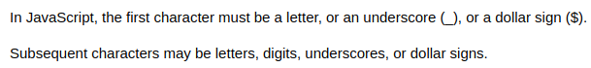

## JavaScript and Camel Case

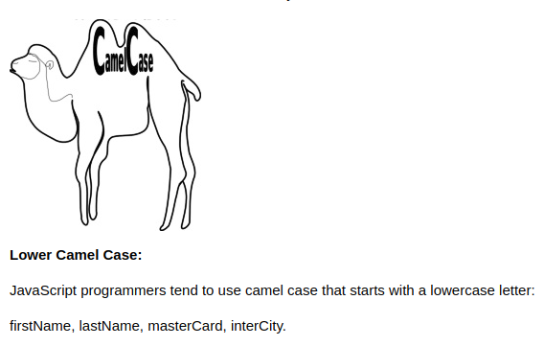

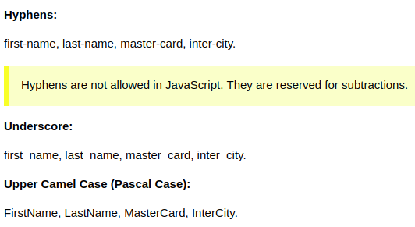

## The For Loop

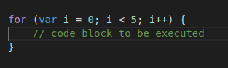

## The For/In Loop



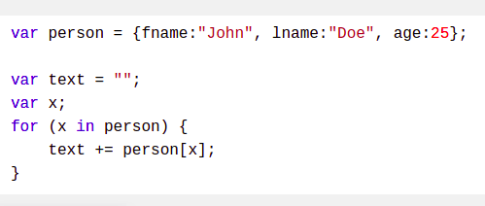

Ex:

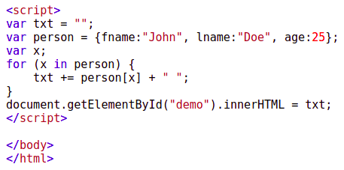

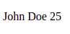

## The While Loop

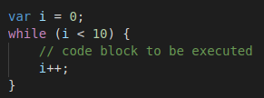

## The Do/While Loop

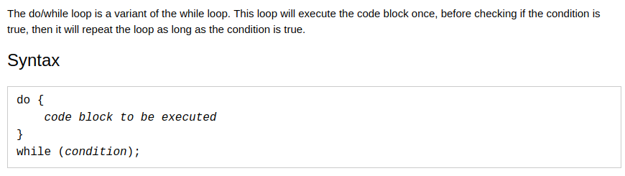

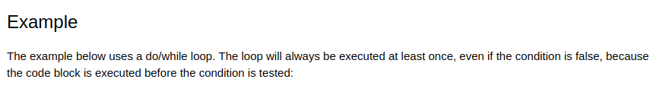

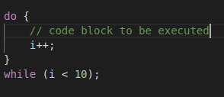

## Comparing For and While

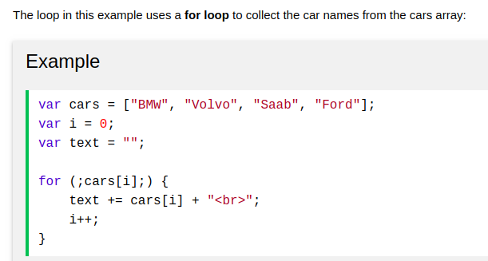

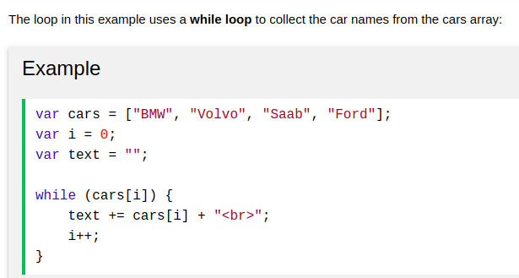

# JavaScript Functions

Ex:

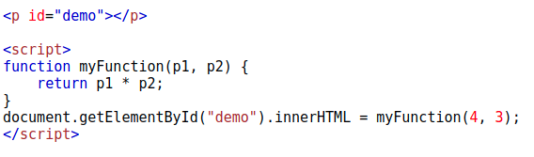

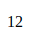**--------------------------------------------------------------------**

important

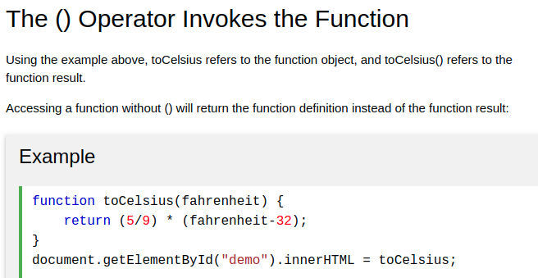

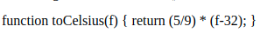

**--------------------------------------------------------------------**

important

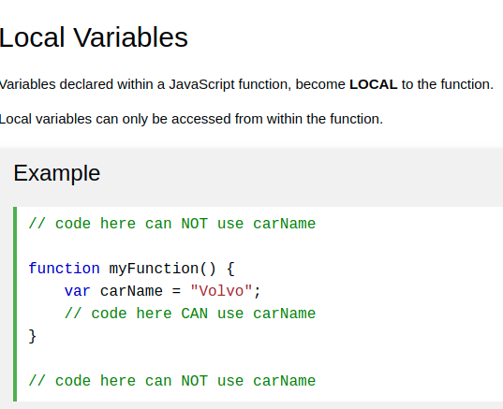

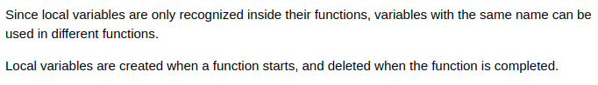

**--------------------------------------------------------------------**

Note: js function is hoisted

**--------------------------------------------------------------------**

## ( Important ) Function Return

When JavaScript reaches a return statement, the function will stop executing.

Ex: recursive function will stop will reaches a return

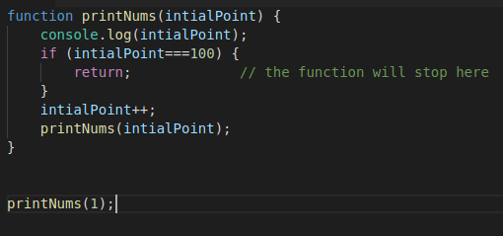

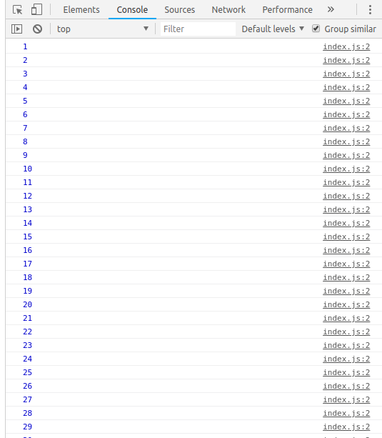

## Variables

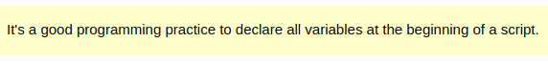-------------

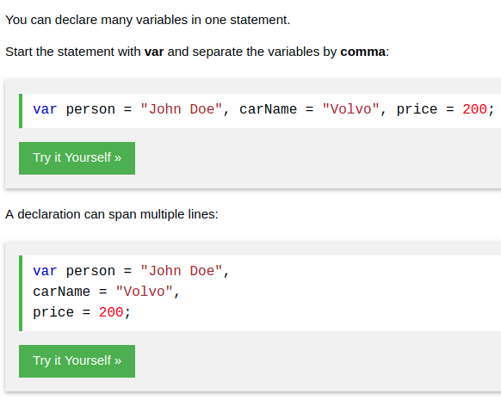

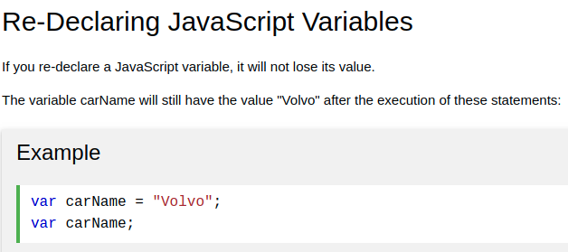

# JavaScript Let and const

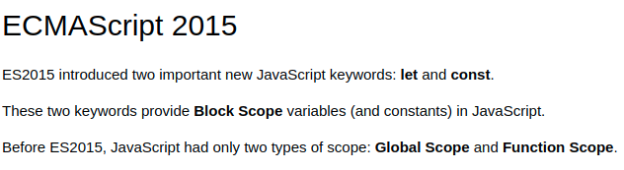

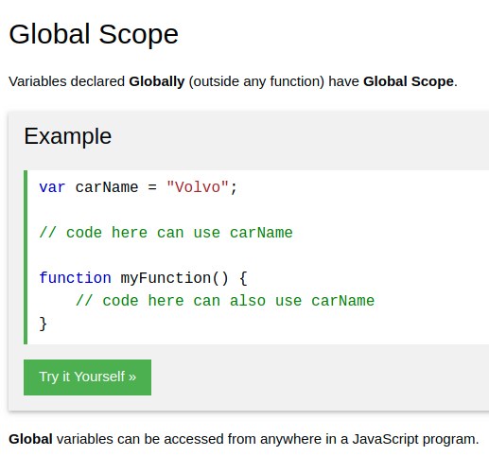

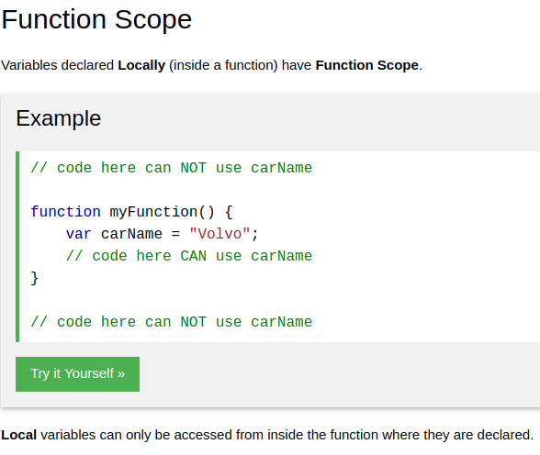

………………………….

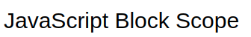

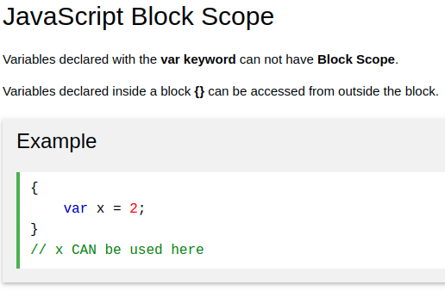

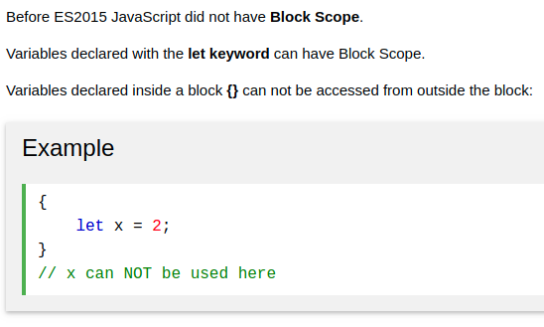

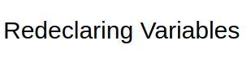

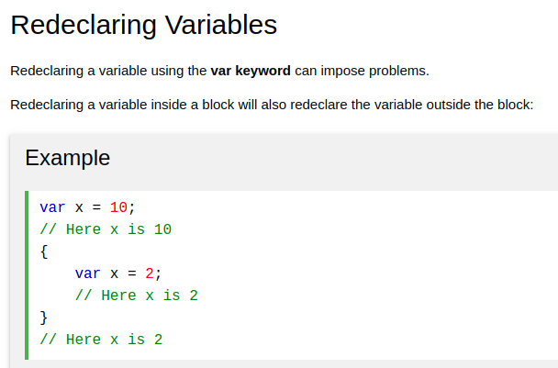

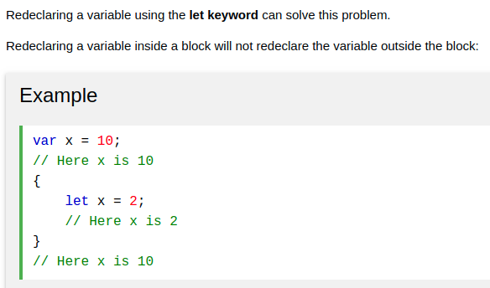

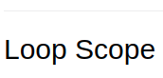

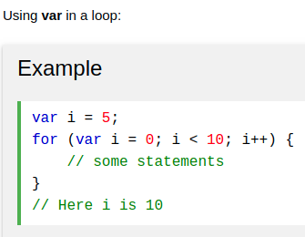

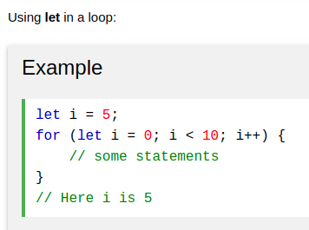

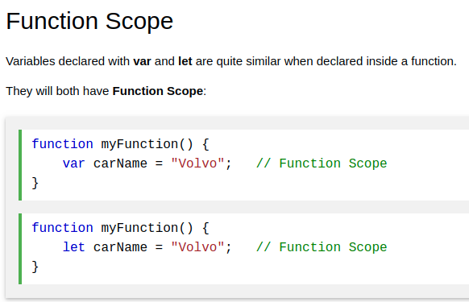

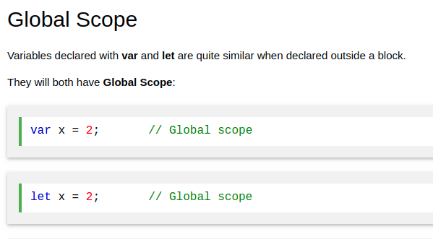

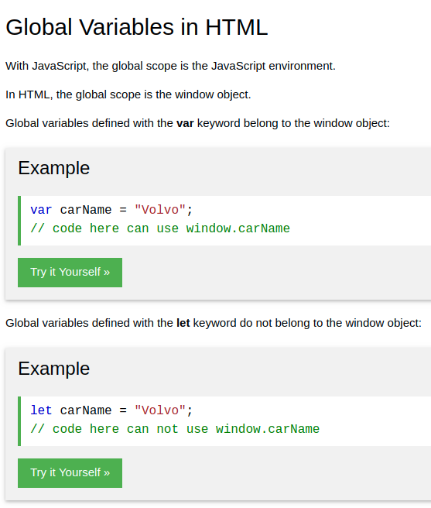

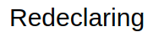

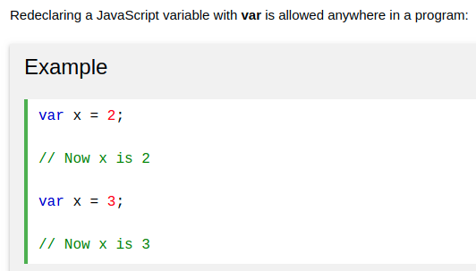

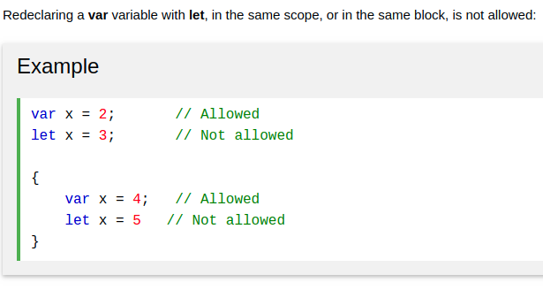

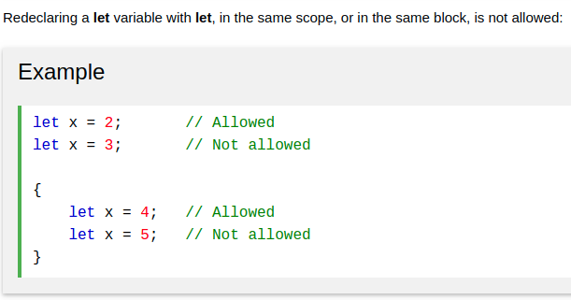

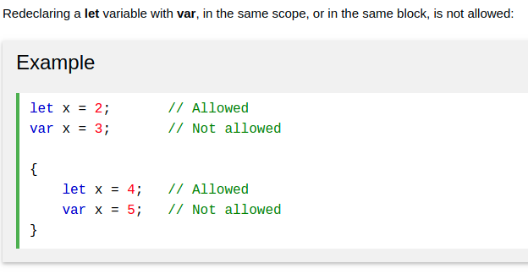

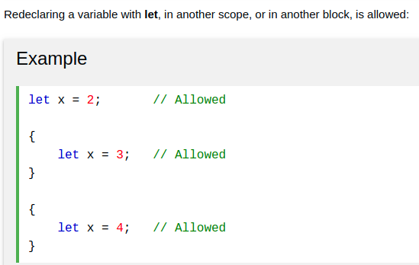

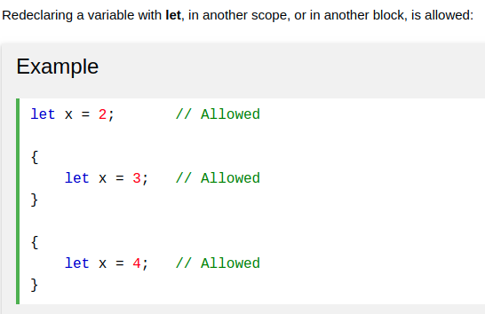

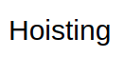

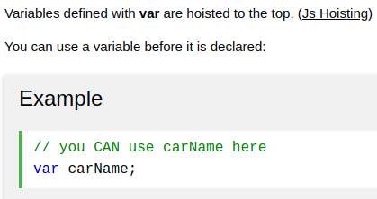

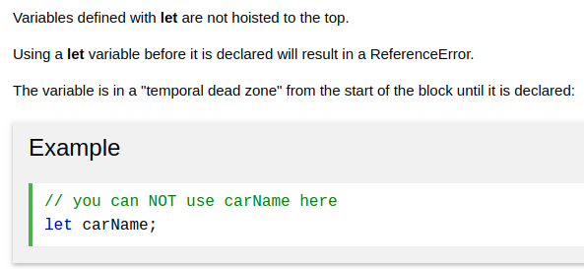

# JavaScript Const

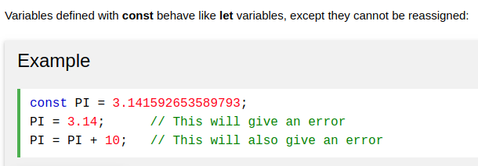

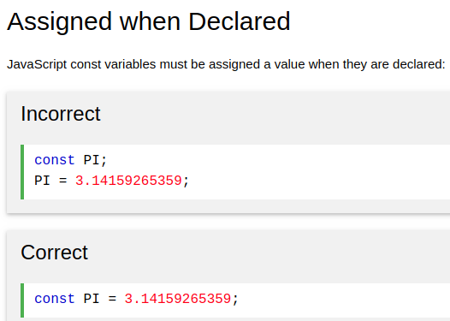

IIFE's Function

An IIFE (Immediately Invoked Function Expression تعبير دالة مستحث فورا) ,

is a JavaScript function that runs as soon as it is defined يتم تشغيلها بمجرد تحديدها.

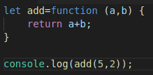

Note: The IIFE's Function is not Hoisting

**Functional programming (interview question)**

**= function Argument as function(x, y, function)**

the function accepts an argument(variable) as function.

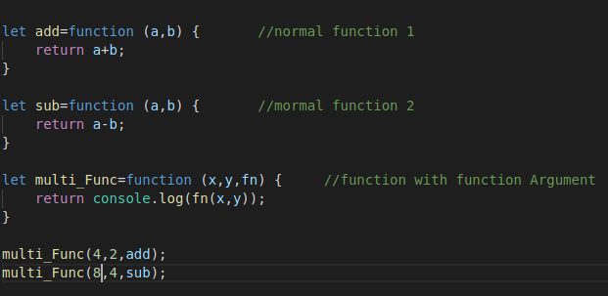

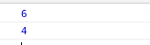

**Objected-oriented programming**

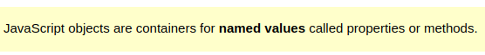



Ex1:



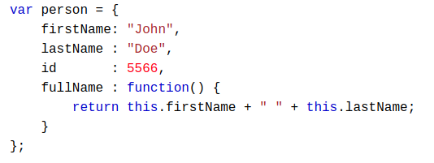

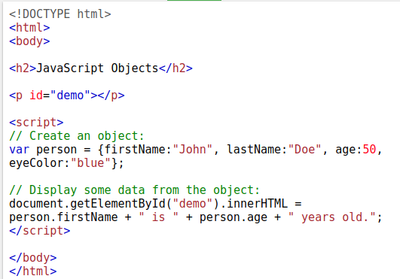

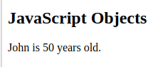

Ex2:

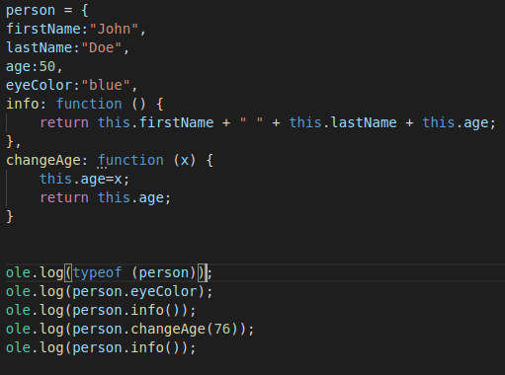

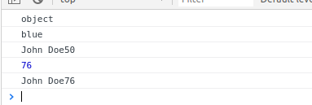

**Note: it can to create new properties later without declaring in the object.**

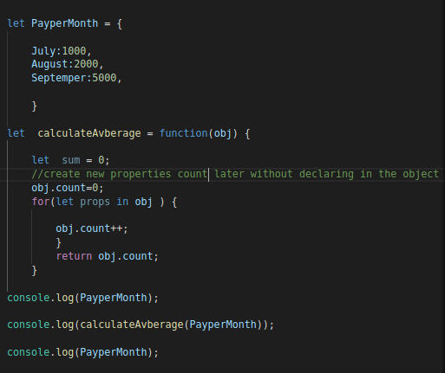

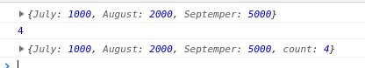

**Object Inheritance**

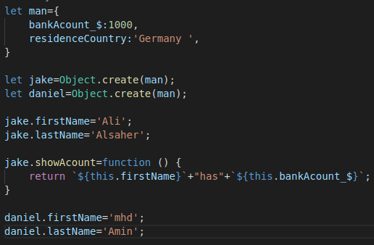

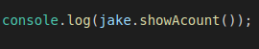

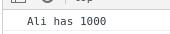

or

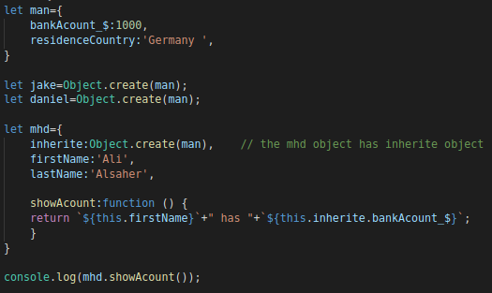

**this**

In a function definition, this refers to the "caller" of the function.

1 - This.numOfsales +=; ===> this=owner the function

2- if an object( ALI ) calls the above via inherits ===> this=ALI

that means This.numOfsales=ALI. NumOfsales

so the compiler will replace “this” with “ALI”.

Ex:

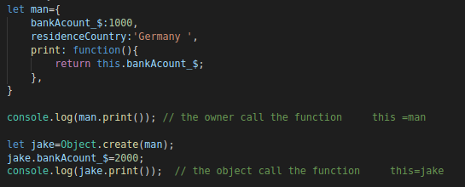

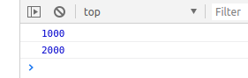

**JavaScript Arrays**



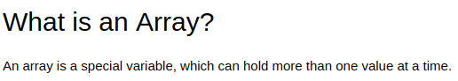

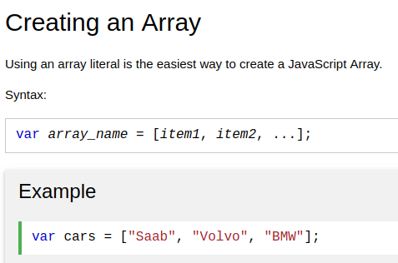

the data type of array is : object

ex:

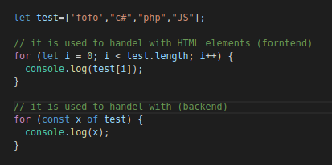

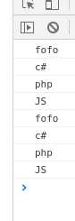

the first item is ; [0]

the last item is ; [length - 1]



**Array.includes() to compare**

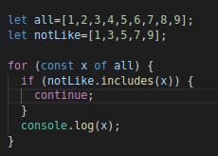

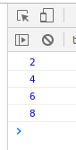

Array's methods

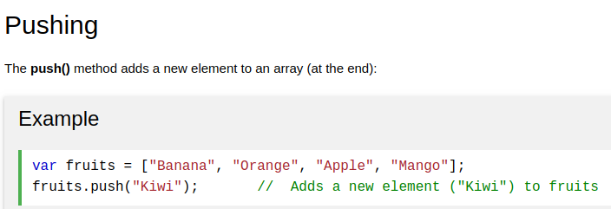-------------------------------------------

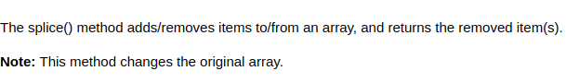

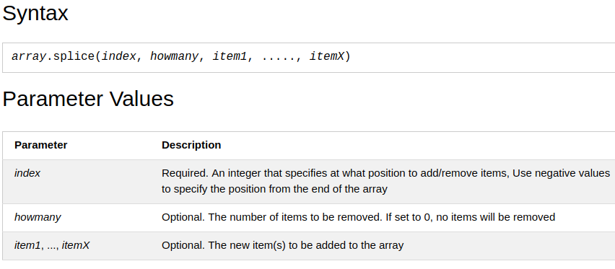

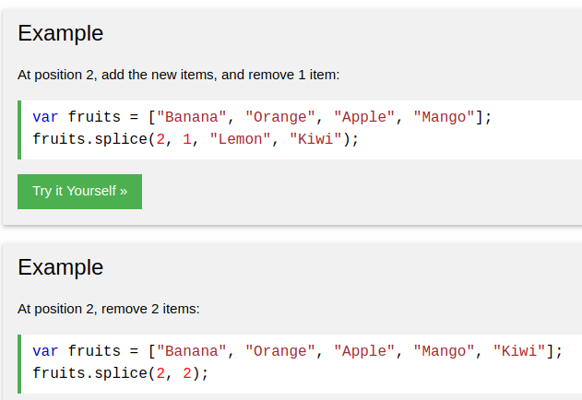

**-------------------------------------------------------**

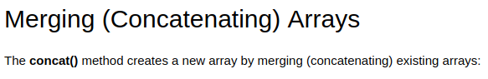

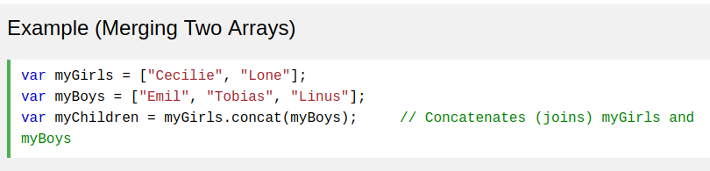

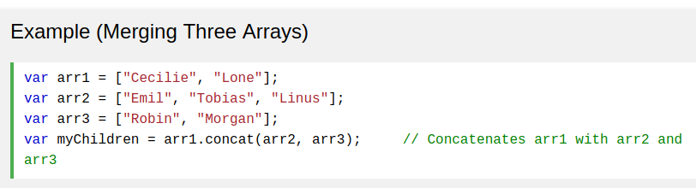

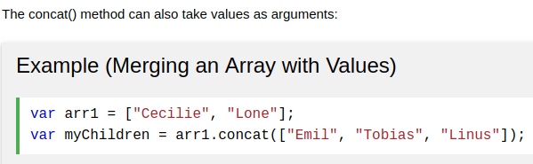

**to reverse array array.reverse()**

**to sort array array.sort()**

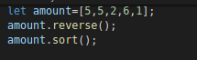

or

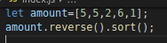

## Converting an Array to String

**array.join()**

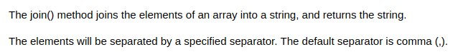

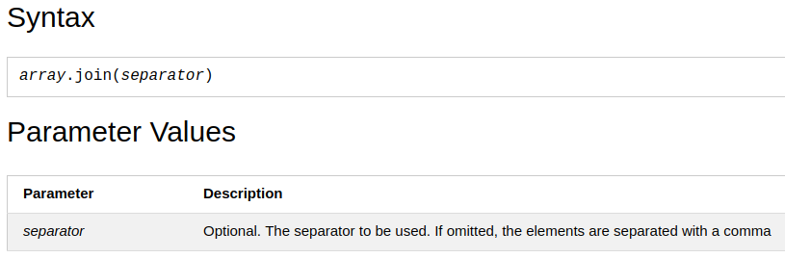

**ex:**

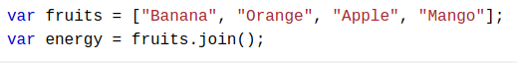



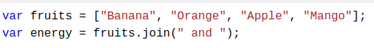

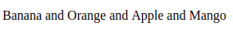

## Converting a String to an Array

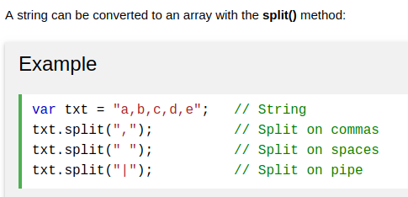

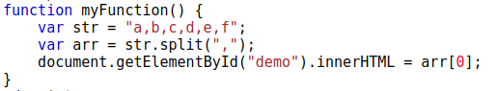

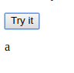

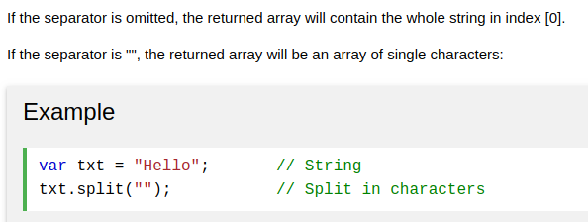

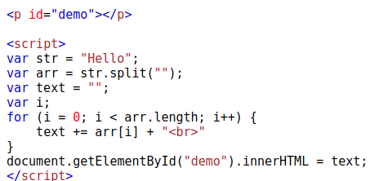

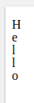-----------------------------------------------------------------------------------------------

# String Variable is like array

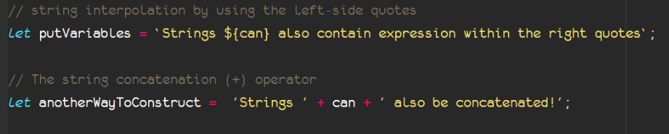

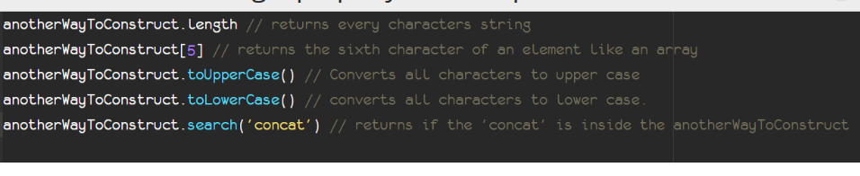

# Nested Arrays

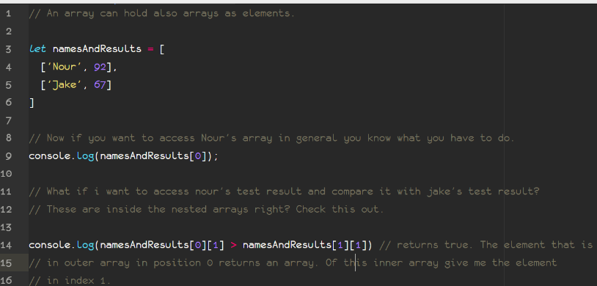

Ex:

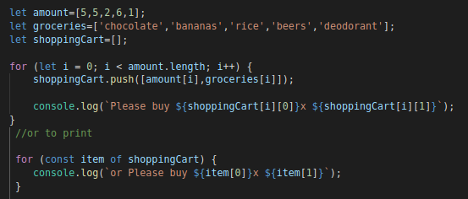

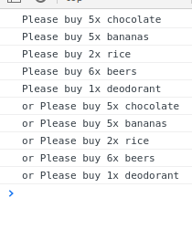

inheritance ( Constructor+Prototype )

**1-New Constructor منشئ جديد**

Another way to create objects is by creating a constructor pattern and then fill the properties with the values as shown

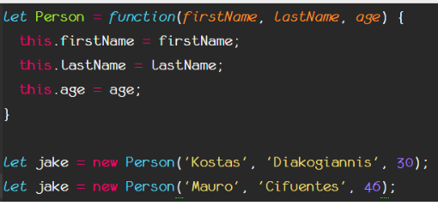

**2-New Constructor+** Prototype inheritance

A better way to set an object to inherit the properties of another object is by the Object.setPrototypeOf.

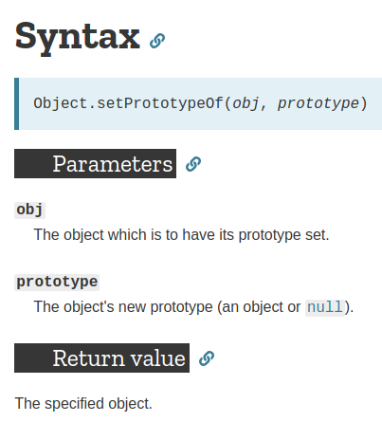

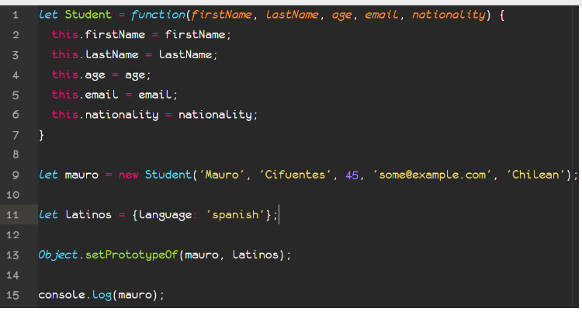

# Date Objects

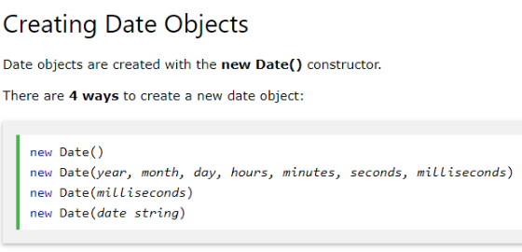

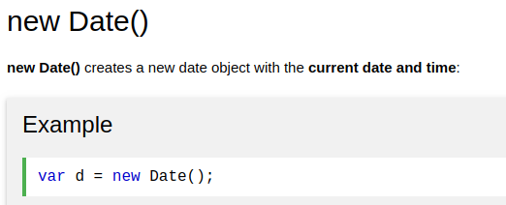

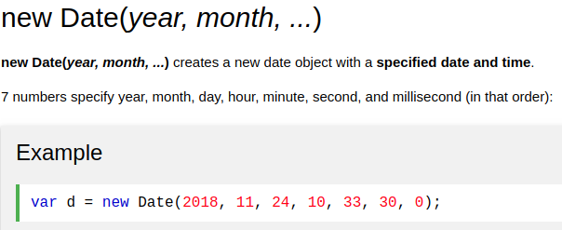

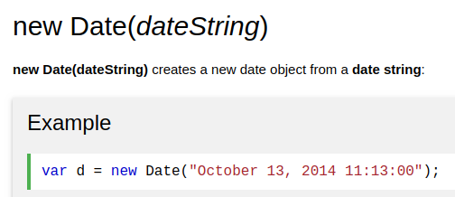

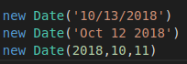

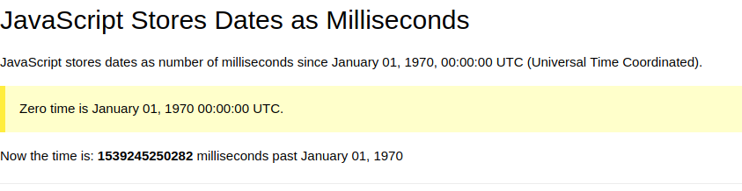

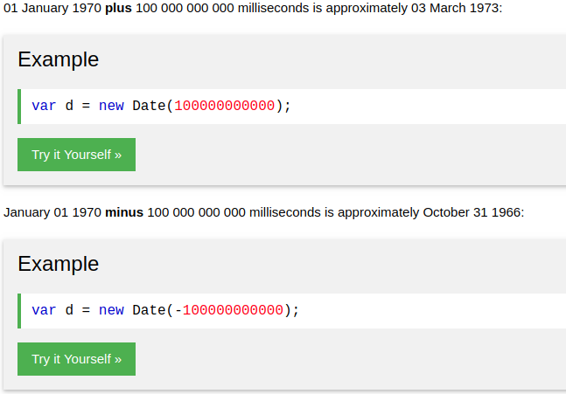

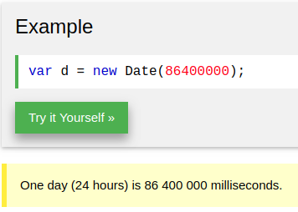

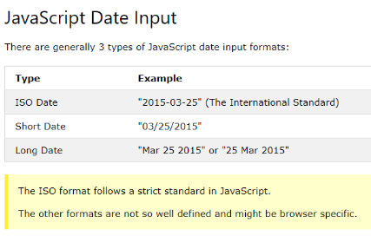

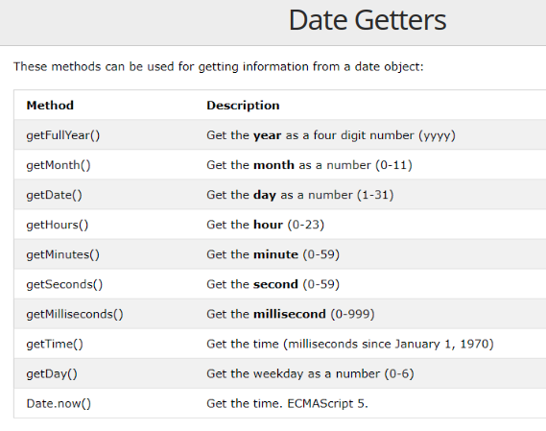

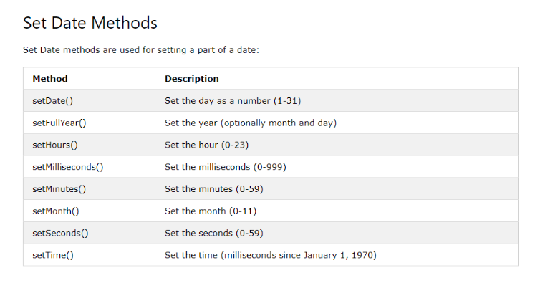

**Return**

Return will break everything ( function, while, for, if, ………) in any code.

That mean the last line will execute, is “Return”.

# JavaScript Array find() Method

**Or high order function for array**

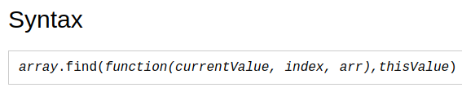

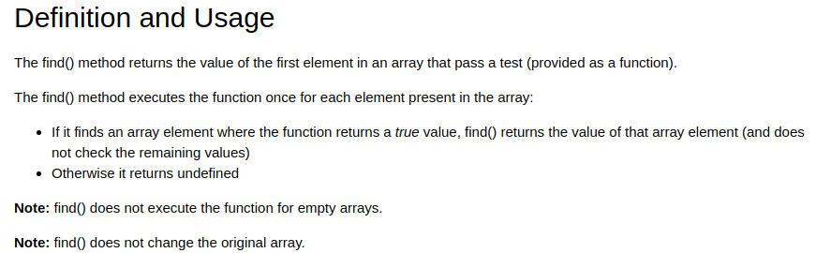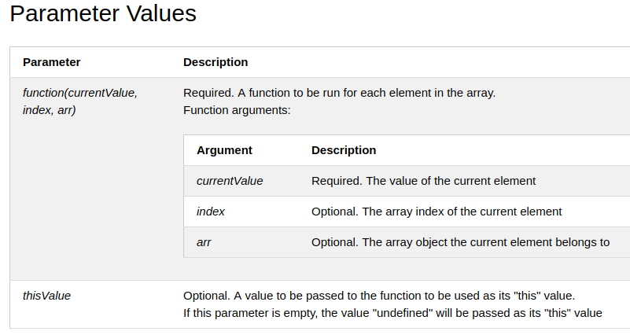

Ex:

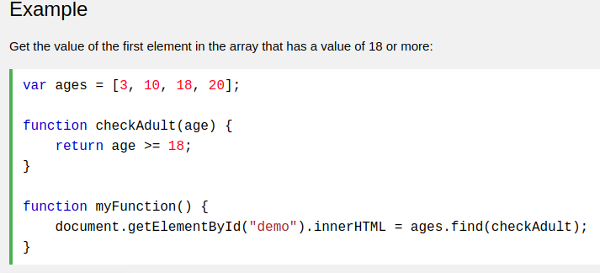

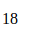

## JavaScript Assignment Operators

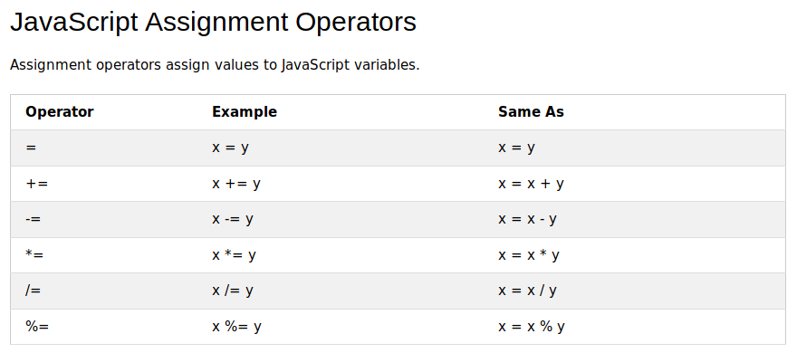

# Timing Events

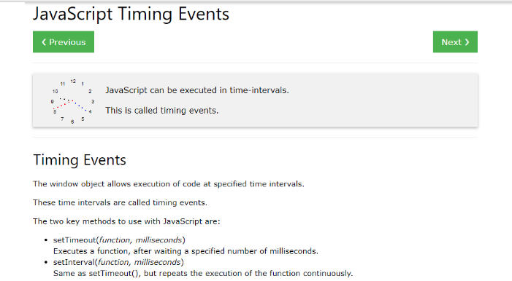

Attention: Both timing events (setInterval and setTimeout) run asynchronously.

Setting an interval function

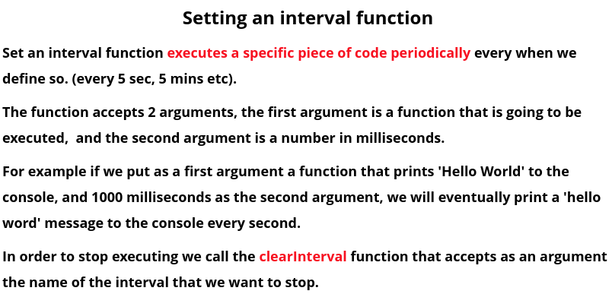

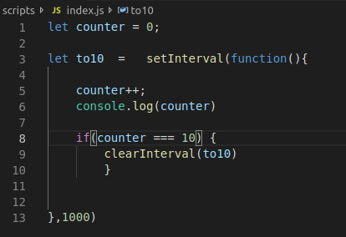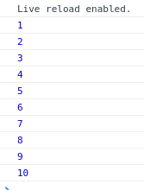

Setting a timeout function

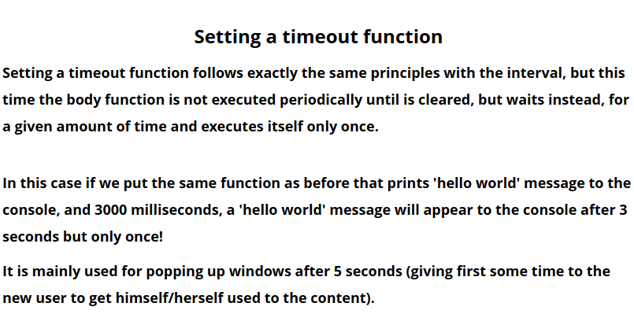

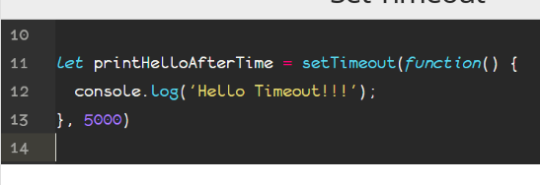  
Selecting DOM elements

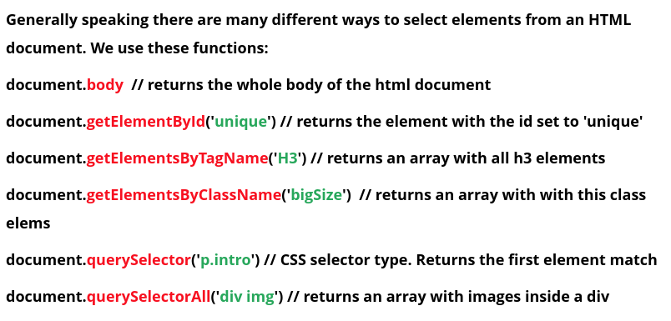

# **HTML DOM querySelector() Method**

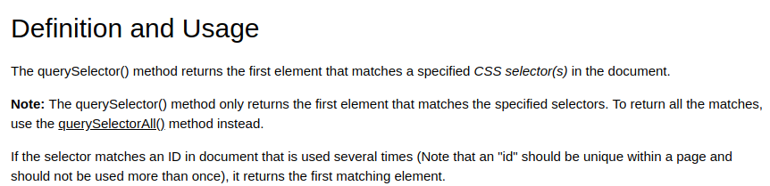

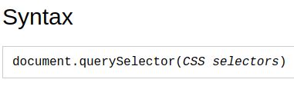

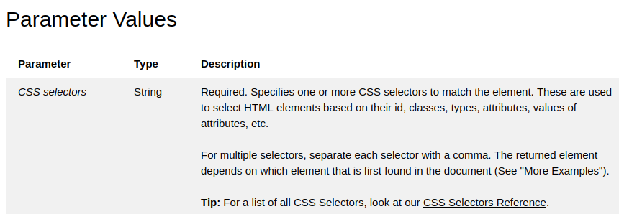

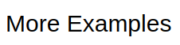

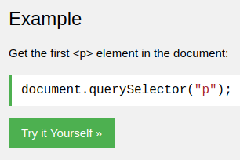

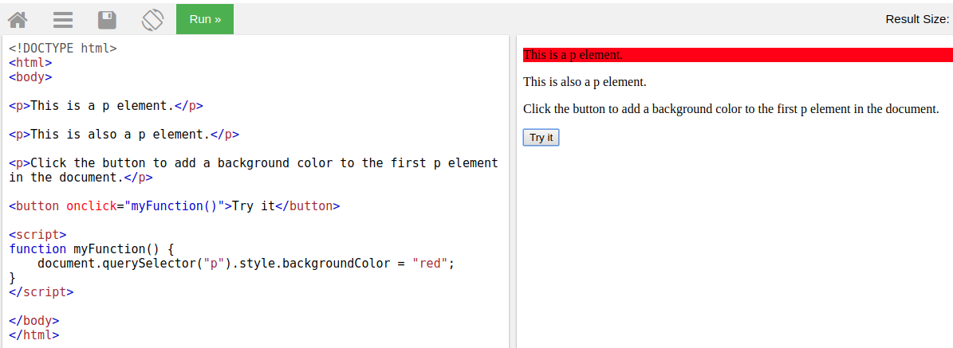

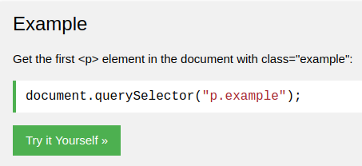

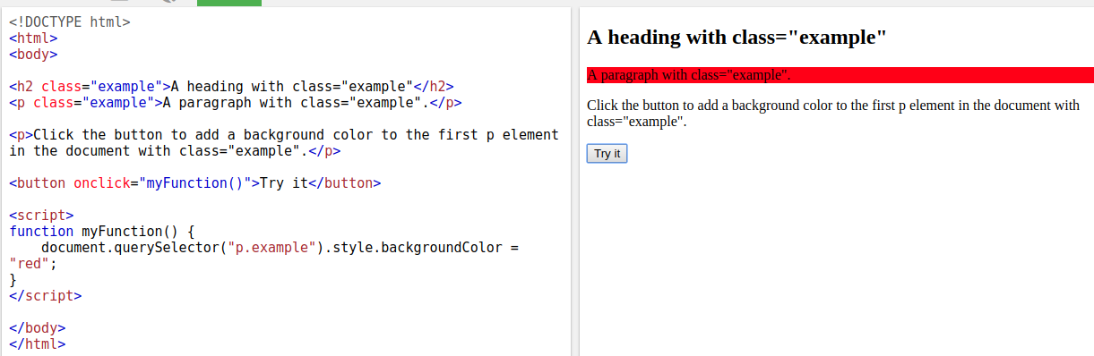

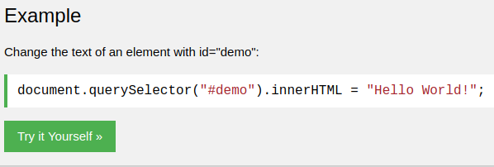

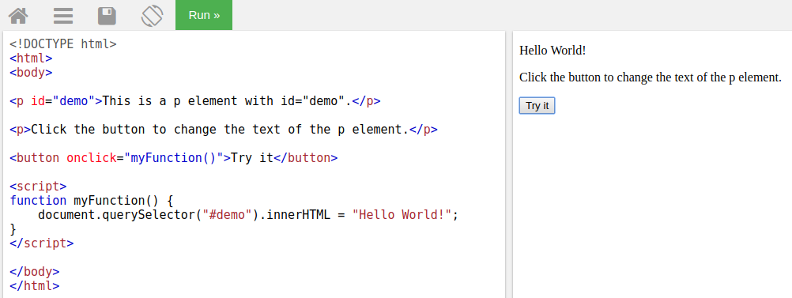

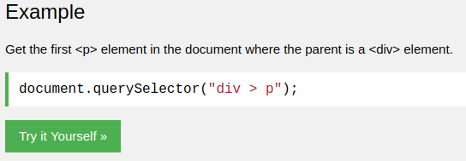

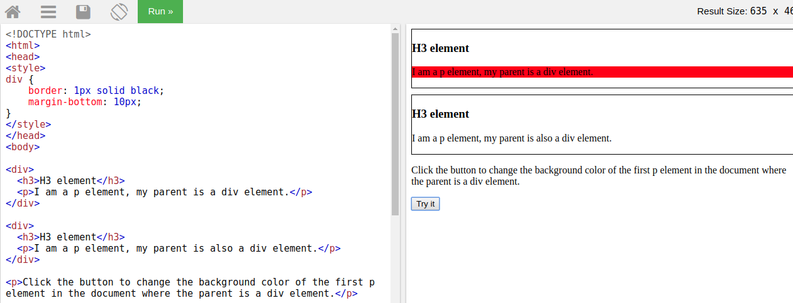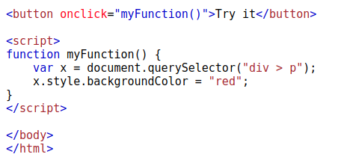

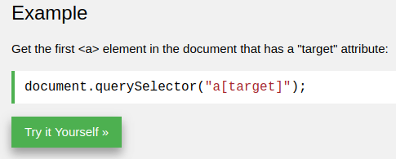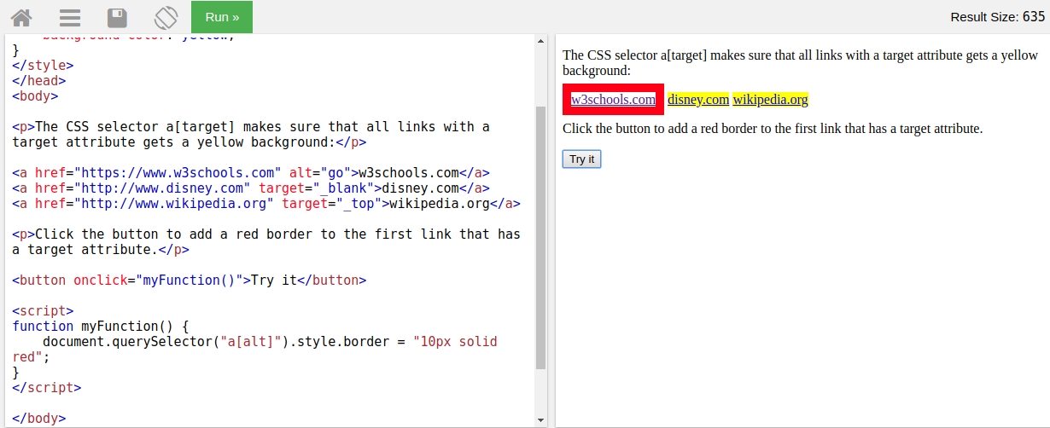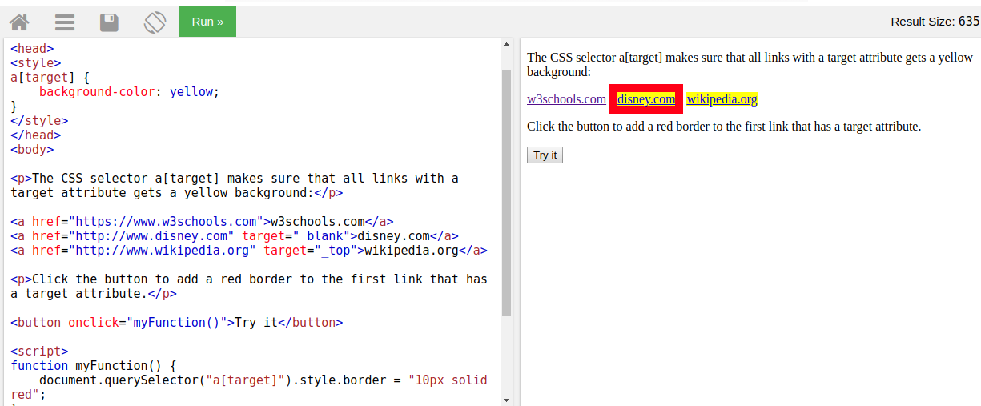

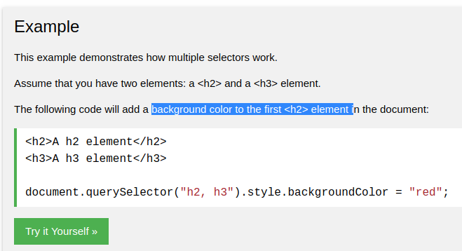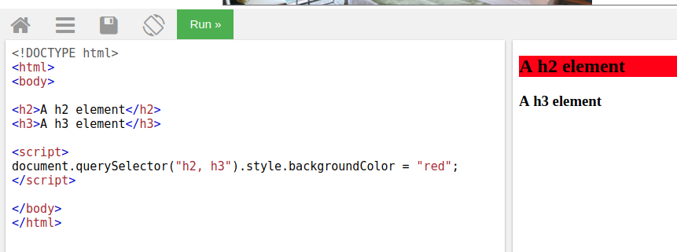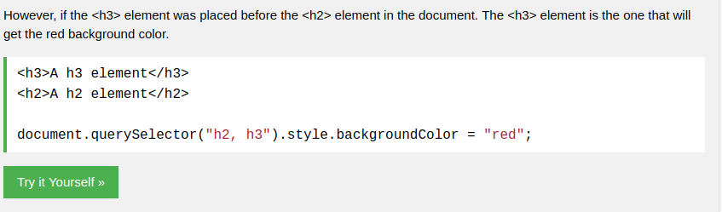

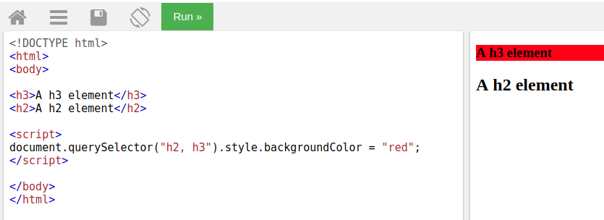

# **HTML DOM classList Property**

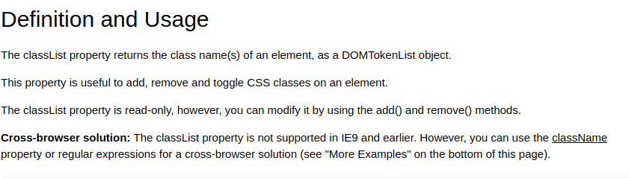

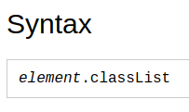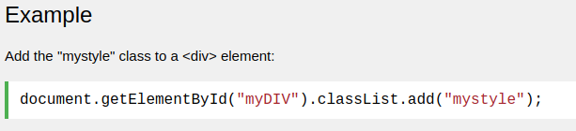

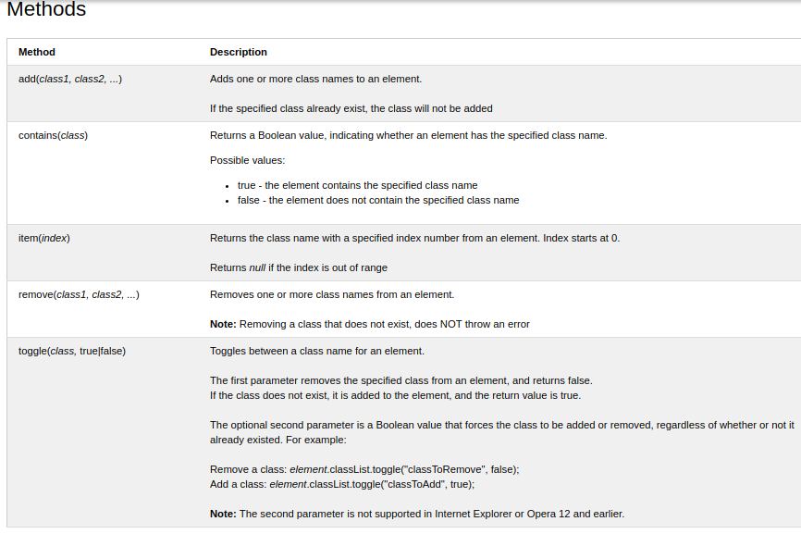

# stopPropagation()  نشر Event Method

Propagation means bubbling up to parent elements orcapturing down to child elements. **يعني الانتشار فقاعات تصل إلى العناصر الرئيسية أو الالتقاط إلى العناصر الفرعية**.

The stopPropagation() method prevents propagation of the same event from being called.

Or

the element that has stopPropagation() , it will not respond to any addEventListener() from the parent.

Ex:

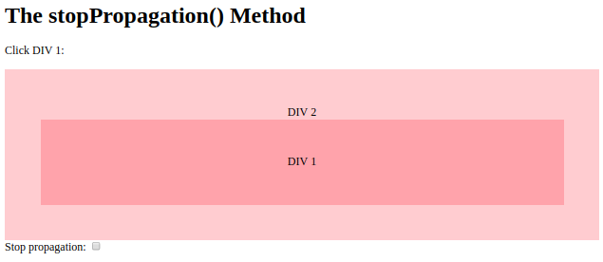

<https://www.w3schools.com/jsref/tryit.asp?filename=tryjsref_event_stoppropagation>

# HTML DOM classList Property

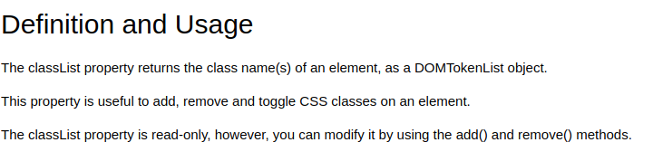

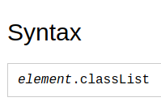

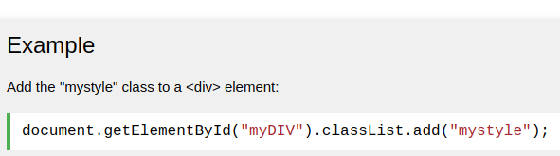

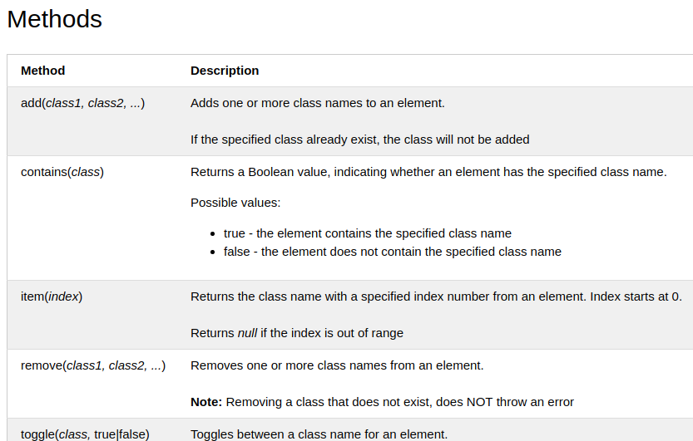

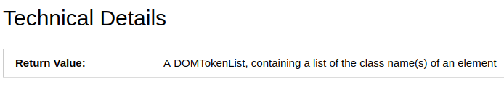

## More Examples

<https://www.w3schools.com/jsref/prop_element_classlist.asp>

# preventDefault() Event Method

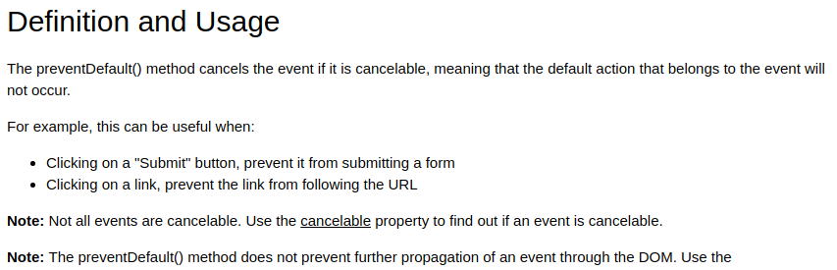

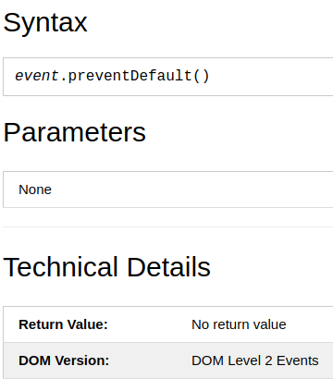

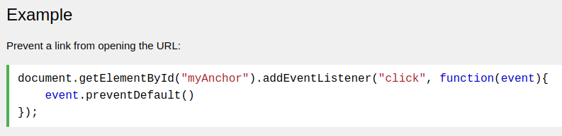

# Window scrollBy() Method

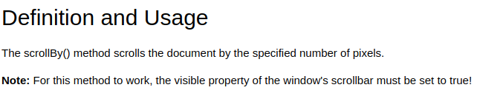

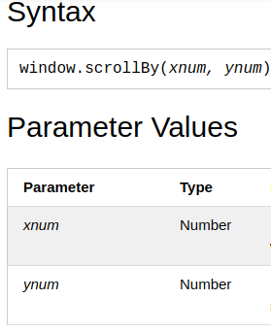

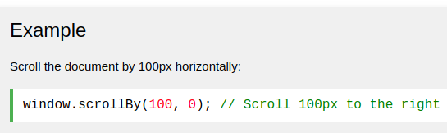

## More Examples

<https://www.w3schools.com/jsref/tryit.asp?filename=tryjsref_win_scrollby3>

# Window pageXOffset and pageYOffset Properties

Where is my scroll pixels.

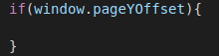



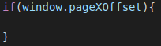

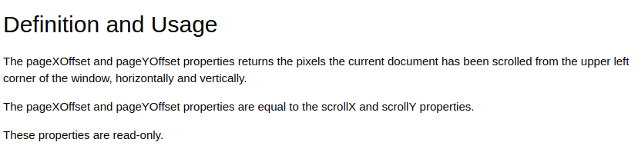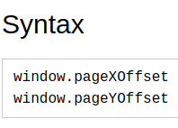

# Element offsetTop Property

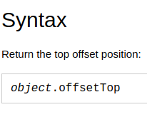

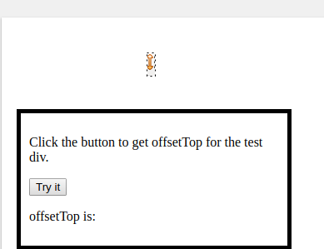

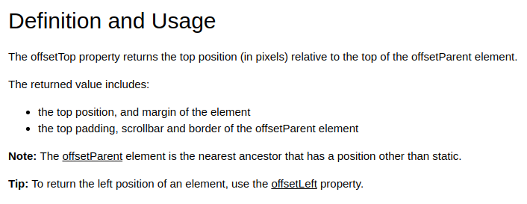

Ex 69_scrollby :

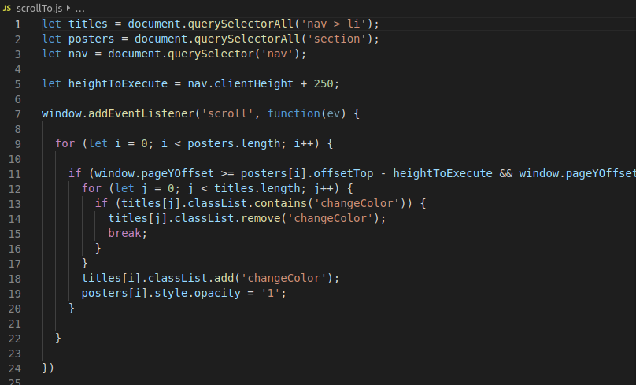

# HTML DOM clientHeight Property

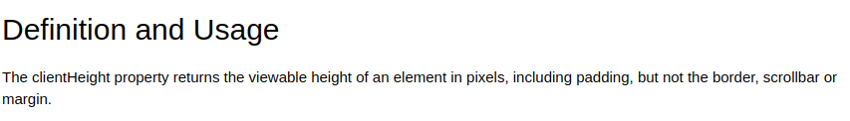

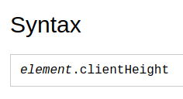

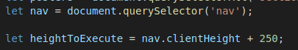

# MouseEvent clientX Property

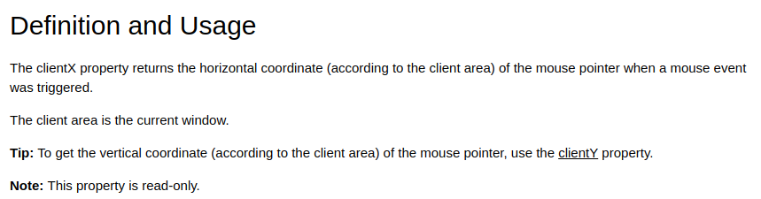

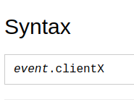

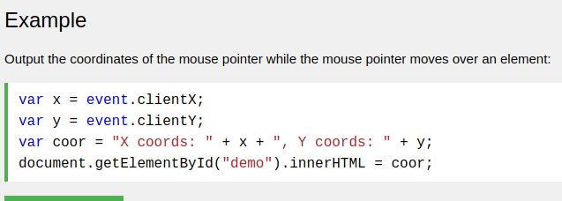

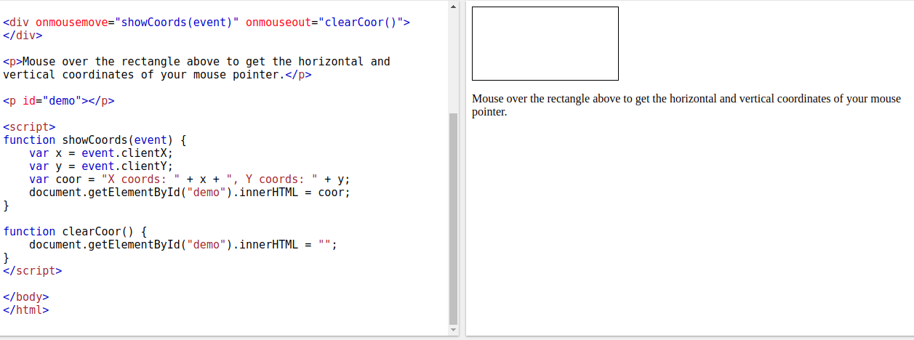

https://www.w3schools.com/jsref/tryit.asp?filename=tryjsref_event_mouse_clientxy2

# currentTarget Event Property

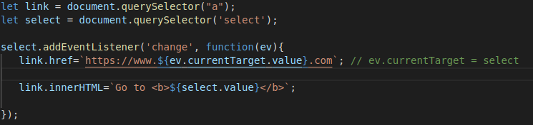

# CSS z-index Property

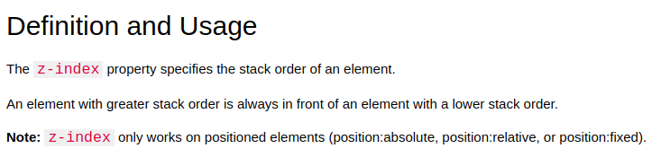





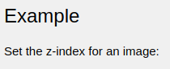

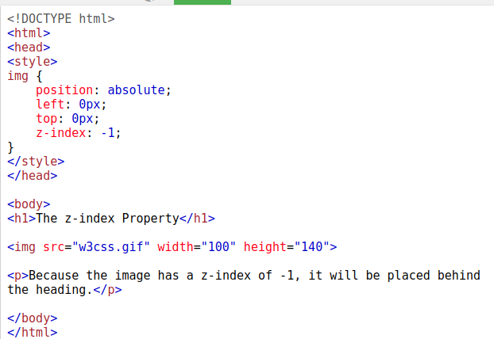

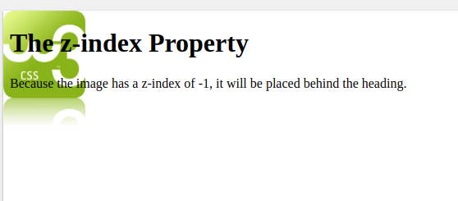

WHEN NO POSITION, **z-index** will not effect anything to image.

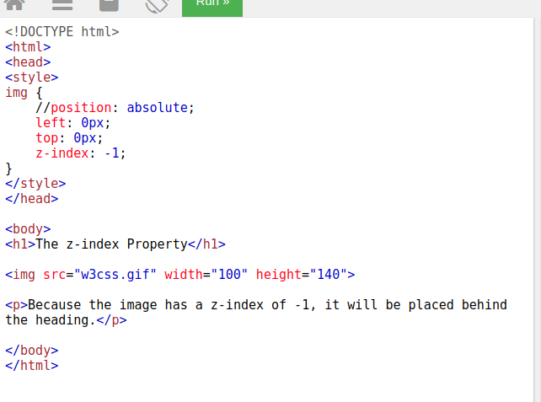

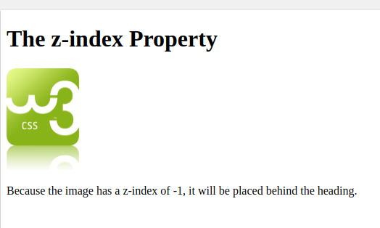

**document.addEventListener ( 'DOMContentLoaded', function (ev) {**

your js code

**})**

## -The HTML DOM (Document Object Model) = to access all Html elements after loaded.

-When a web page is loaded, the browser creates a Document Object Model of the page.

-In other words: The HTML DOM is a standard for how to get, change, add, or delete HTML elements.

**domContentLoaded** is the point when both the DOM is ready and there are no stylesheets that are blocking JavaScript execution.

- ( Scenario 1 ) ; when to add a new element on the fly by js with the document method like document.createElement('P'),

so the new element will be after JavaScript line (big problem).

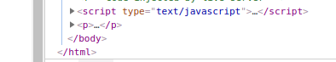

- ( Scenario 2 : to solve the problem of Scenario 1 ) ;

To move the js line to head, so the Html will start with js code , so the js code will call the html DOM eventListeners but the html DOM is not loaded yet. To solve this , it will set “document.addEventListener ( 'DOMContentLoaded', function (ev) {“ in the first line in js, so now the the js code will compile after the HTML DOM is loaded and ready.

So finally now : the element that is added on the fly by js with the document method like document.createElement('P'), will load first then js.

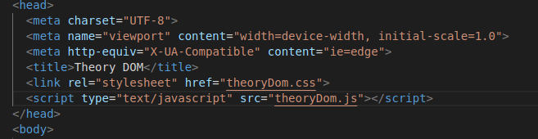

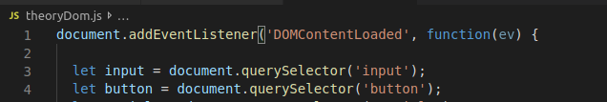

**Input text box**

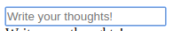



**Input password box**





**Input checkbox**

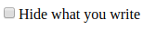



**Select bar**

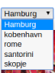

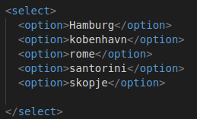

**textarea**

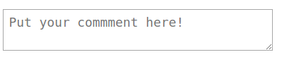



**keyup  event**

The keyup event is fired when a key is released.

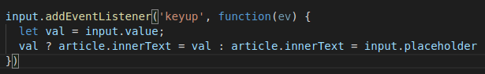

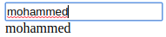

**Select to change img**



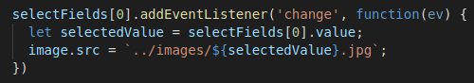

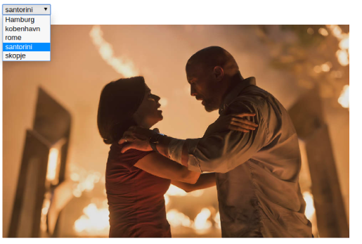

To add a new element on the fly by JavaScript

1- let var = document.createElement('P'); // musr inside ‘ ‘ a capital Letter

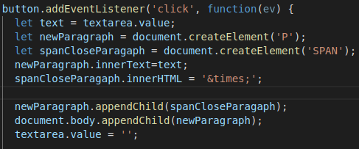2- document.body.appendChild(var); // or element.appendChild(var);

To remove a element on the fly by JavaScript

Element.removeChild(elementToRemove);

ex:

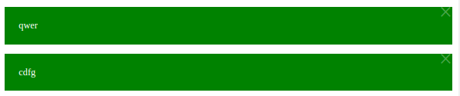

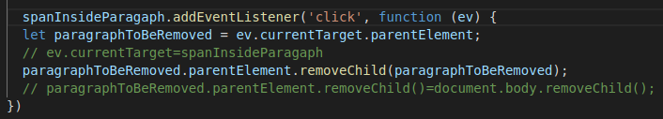

**submit event , it is only with form element**

It mean when I press enter in input box, the event will trigger.

It muss to set <button type="submit"> to button, in order to also the button triggers the submit event of form.

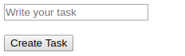

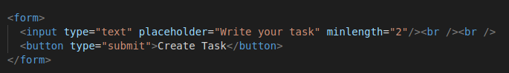

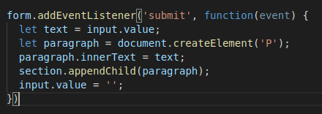

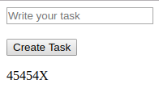

# Window localStorage Property

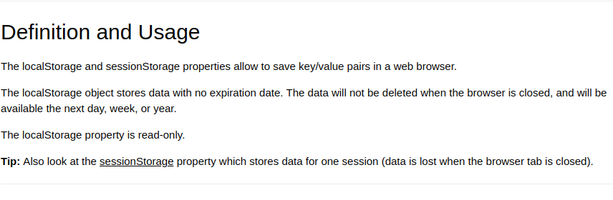

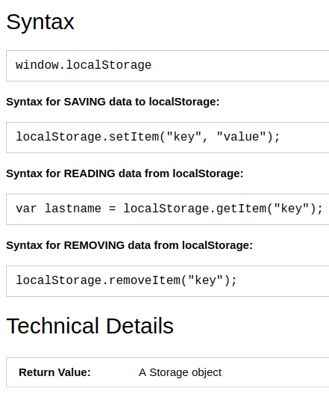

The line of example :

https://www.w3schools.com/jsref/prop_win_localstorage.asp

**how to use it :**



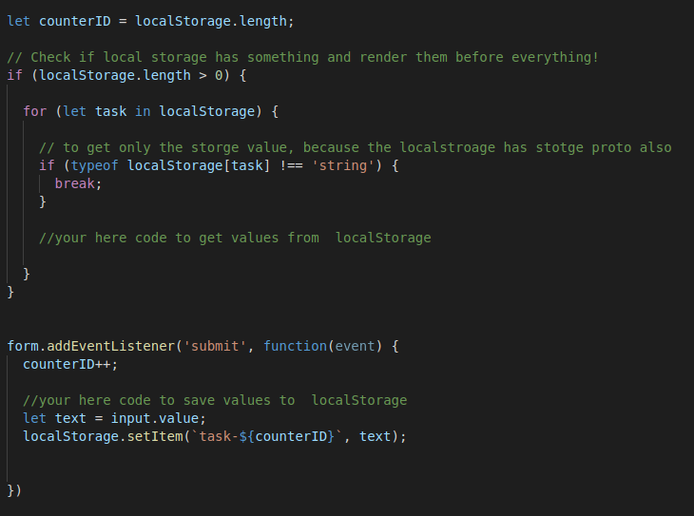

**ex:**

**73_ createElement_on_the_fly with LocalStorg**

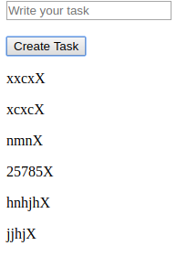

**The <fieldset> tag draws a box around the related elements.**

<fieldset>

<legend>my title</legend>

…… your code

</fieldset>

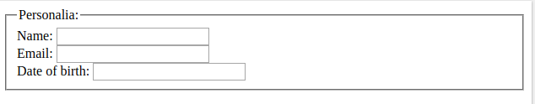

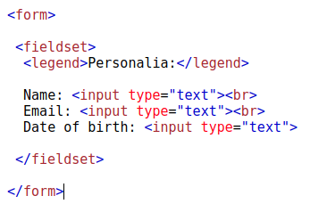

# JavaScript Regular Expressions

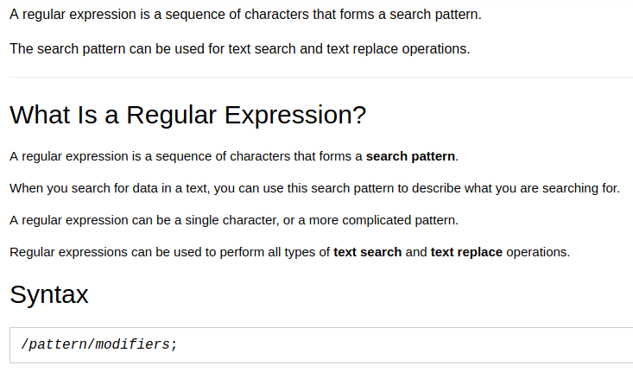**To check regex pattern: www.regex101.com**

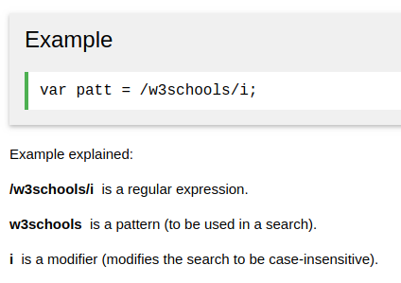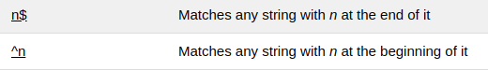

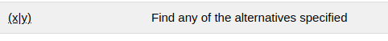

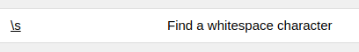



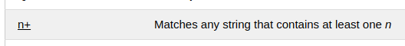

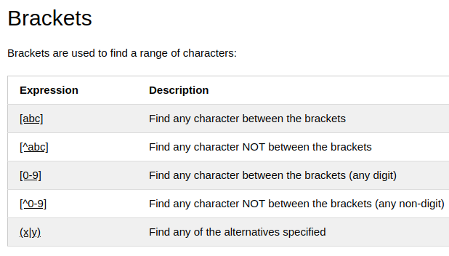

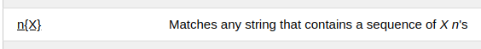

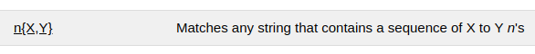

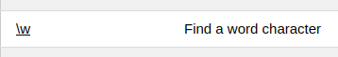

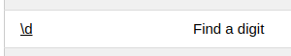

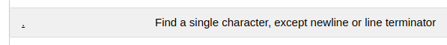

. is everything(word,numbers,sympols)

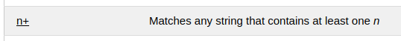

how to write / : slash + symbol = \ /



## **Self-Invoking Functions Invoking:استدعاء it used for security**

It runs only one time and not allow to call it.

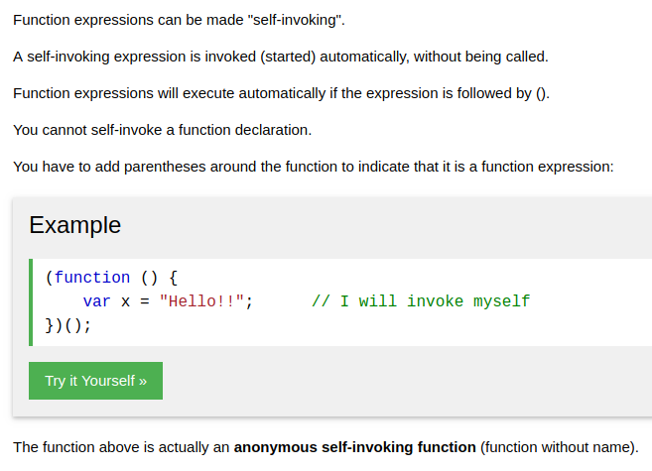

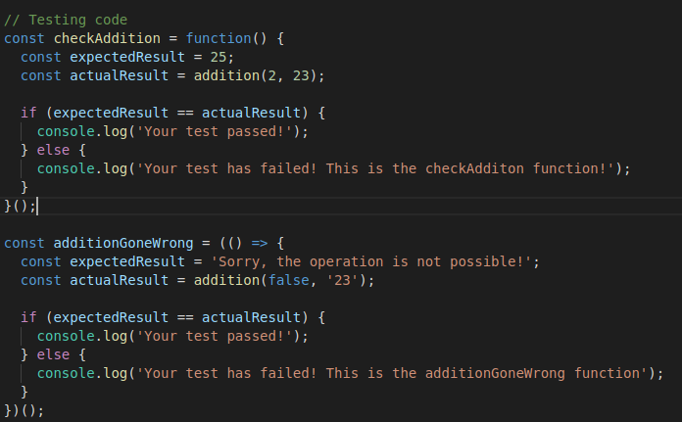

# **ECMAScript 6 - ECMAScript 2015**

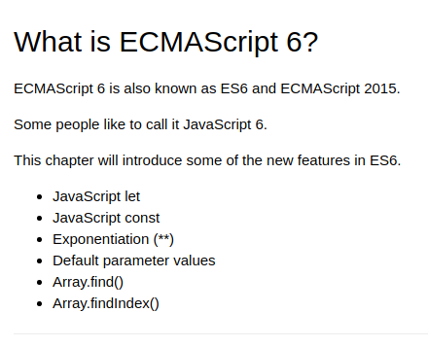

<https://www.w3schools.com/js/js_es6.asp>

Default Values in functions' parameters

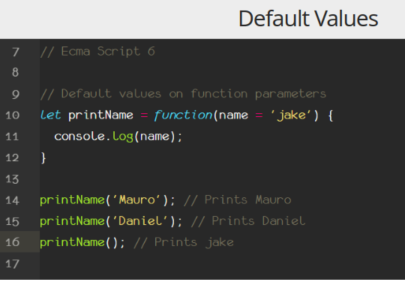

## **Arrow Functions**

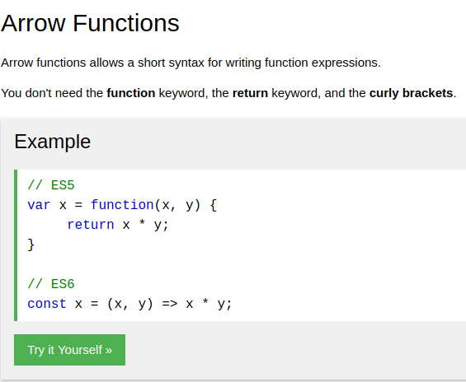

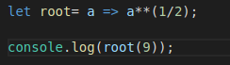

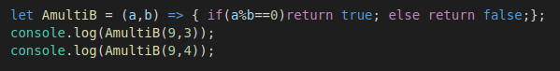

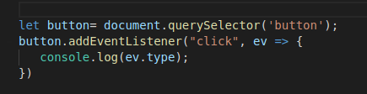

**Set.prototype Constructor (unique values of any type)**

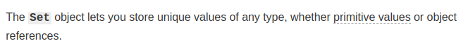

https://developer.mozilla.org/en-US/docs/Web/JavaScript/Reference/Global_Objects/Set

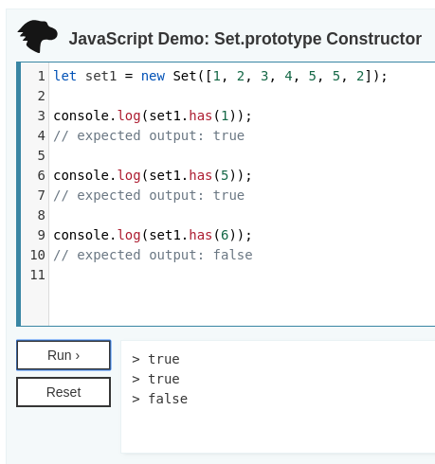

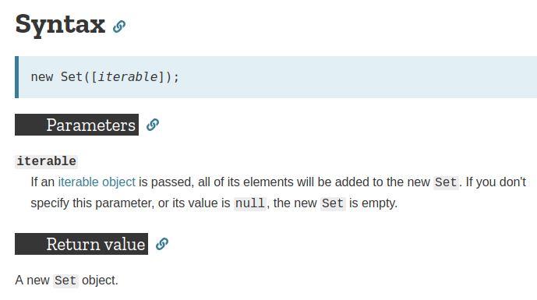

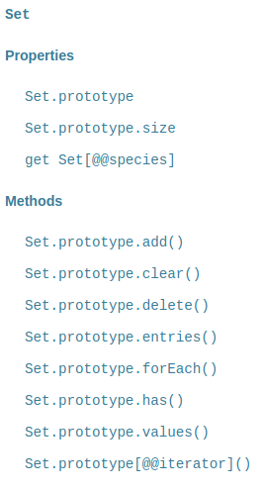

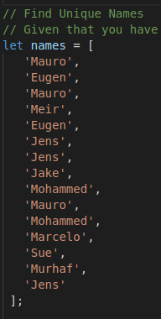

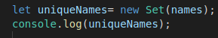

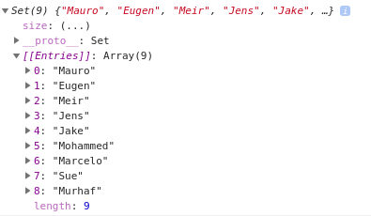

# Class based Inheritance

JavaScript classes, introduced in ECMAScript 2015, are primarily syntactical sugar over JavaScript's existing prototype-based inheritance

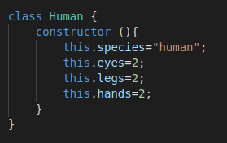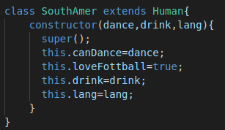

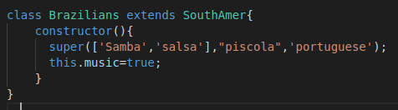

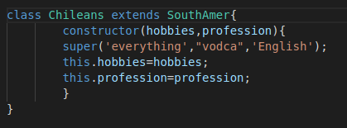

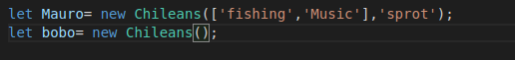

# console.table() Method

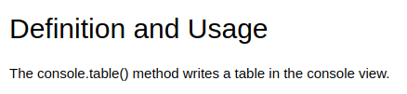

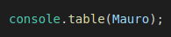

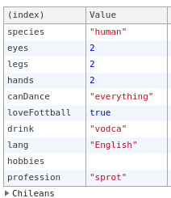

**Asynchronous Code**

it will execute alone in the end of the js file, it will not effect on the main code after it.

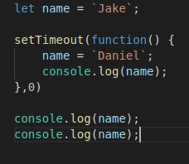

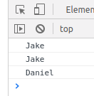

Promises , to create a Asynchronous function

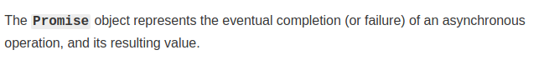

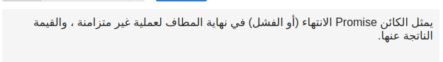

promise object means the 2 option:

completion : ==> resolve ==> .then

failur : ==> reject ==> .catch

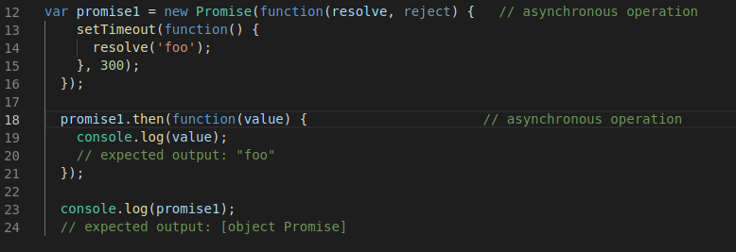

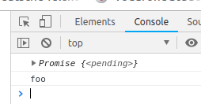

tips to create asynchronous function:

1. create a function with argument(s)

2. create a promise object inside that function

3. resolve (value), reject (message)

4. return promise object to that function

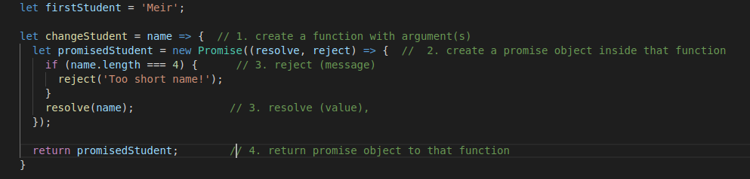

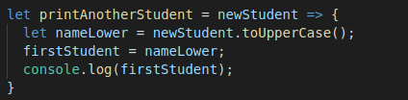

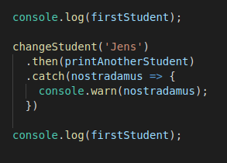

**advance of promise: .all .race**

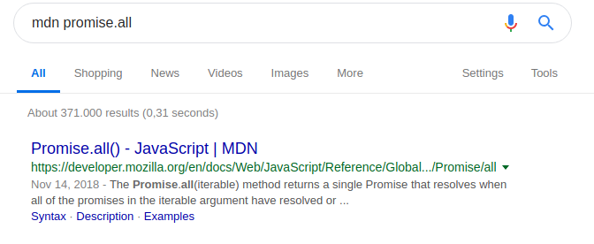

<https://developer.mozilla.org/en-US/docs/Web/JavaScript/Reference/Global_Objects/Promise/all>

f you want to work with a library that deals with promises. Bit advanced to understand though:

http://bluebirdjs.com/docs/features.html

**fetch**

it is ready function to return promise object ( .then , .catch ).

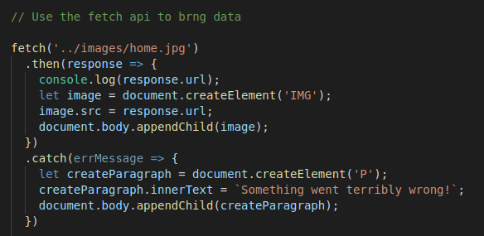

status:

200 success

401 client-error Authorization failed

404 client-error page not found

501 server down

# JSON

**It is encapsulation the data in “ “ then send , so recive the data then decapsulation**

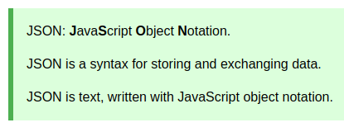

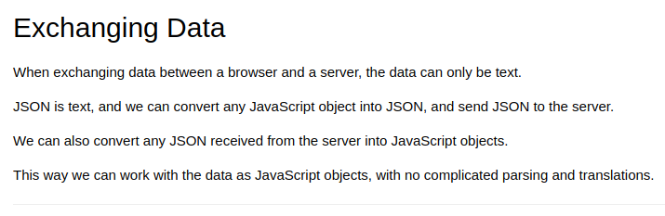

# Try to Catch

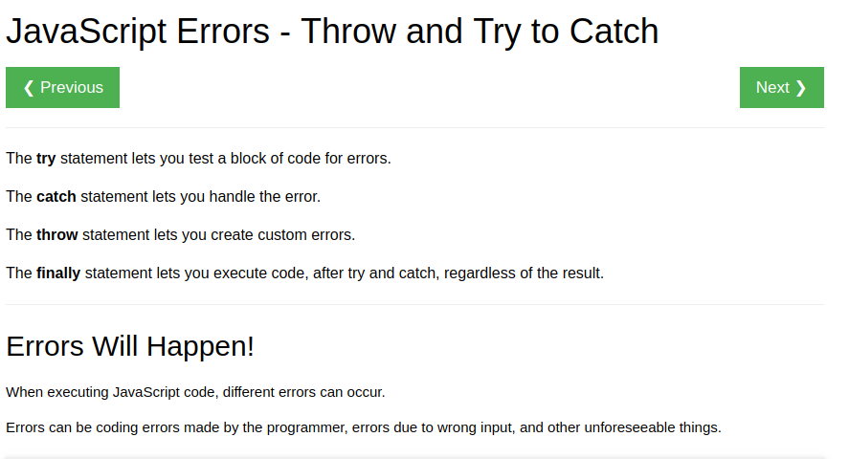

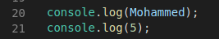

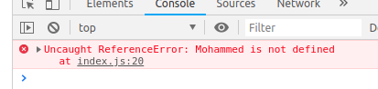

Look the error will prevent to continue the code in line 21.

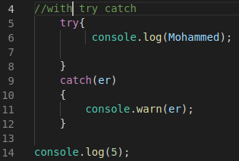

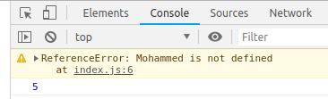

Look the error will **not** prevent to continue the code in line 14.

**async + await ,** to create a Asynchronous function

**it is instead of ‘**Promises , to create a Asynchronous function’

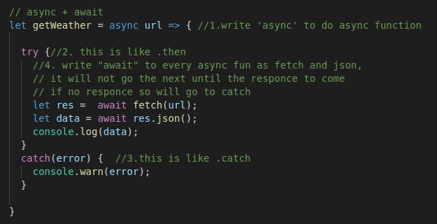

## API

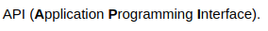

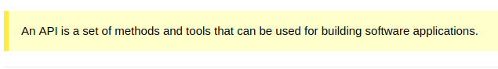

# focus() Method

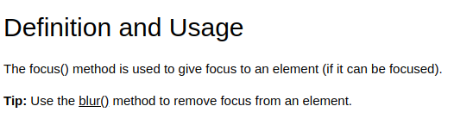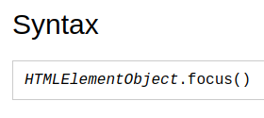

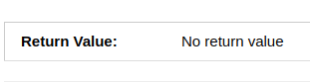



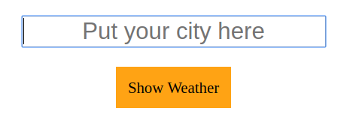

**to use asynchronous function with delay timeout ,** Promise.all

folder: 86_to use asynchronous function with delay timeout

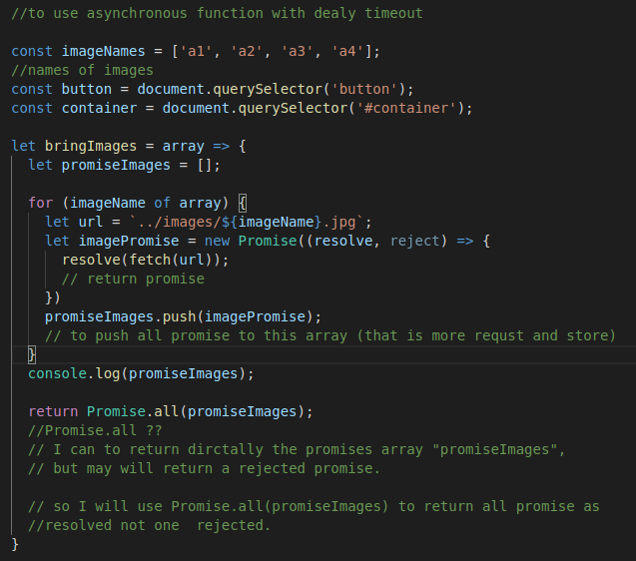

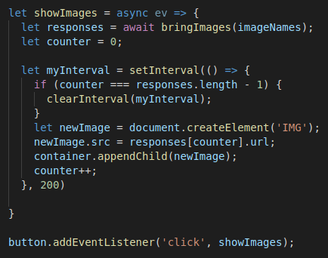

# jQuery

**$(this).**

In JQ ; $(this) = .currentTarget

-not who is called the function in JS

-not working with arrow function =>

**append(), prepend()**

to add children.

**.after , .before()**

To add siblings.

**.remove()**

remove the element itself

**vanilla js vs jQuery**

innerText ==> text()

innerHtml ==> html()

Value ==> val()

**$.ajax(in jQuery) vs Fetch (in vanilla js)**

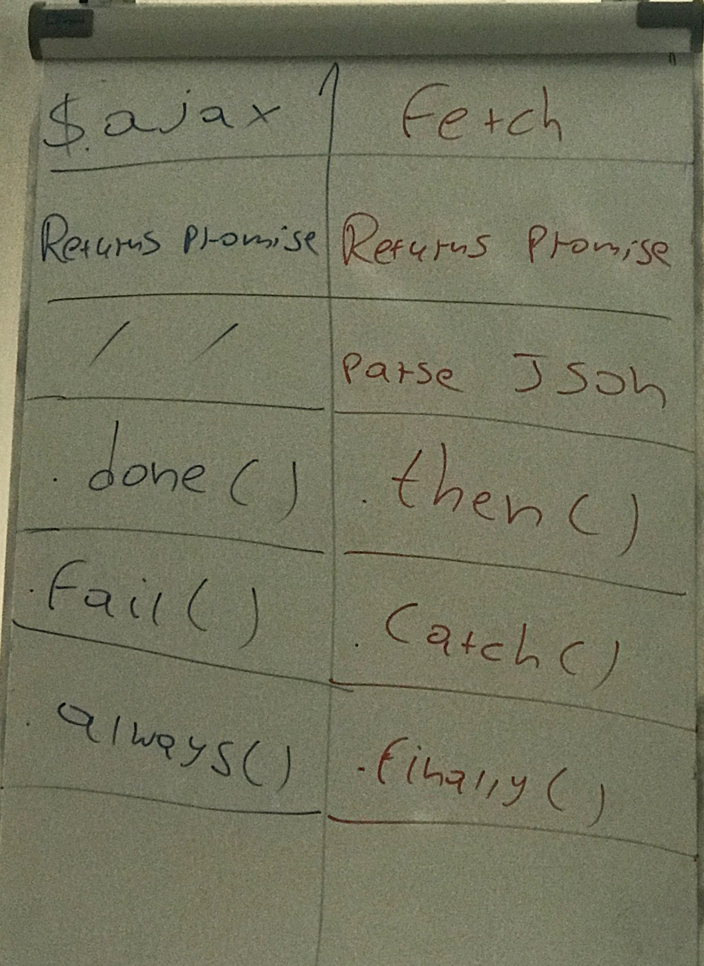

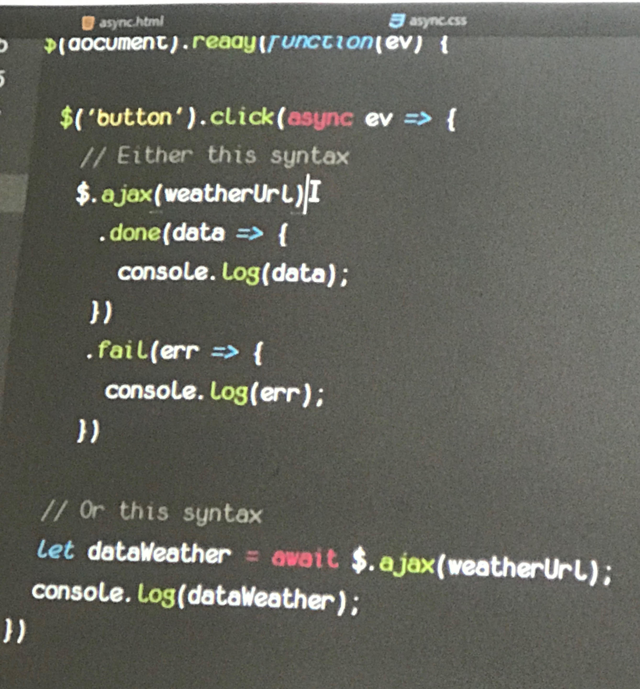

**https://jqueryui.com/**



# Media Queries

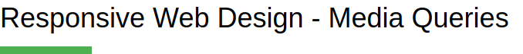

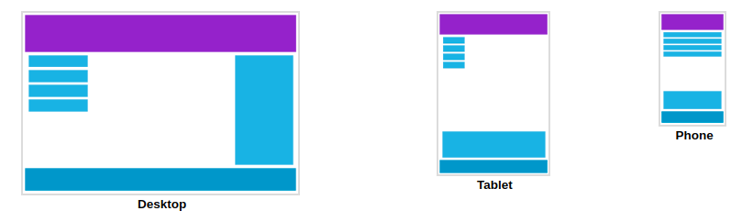

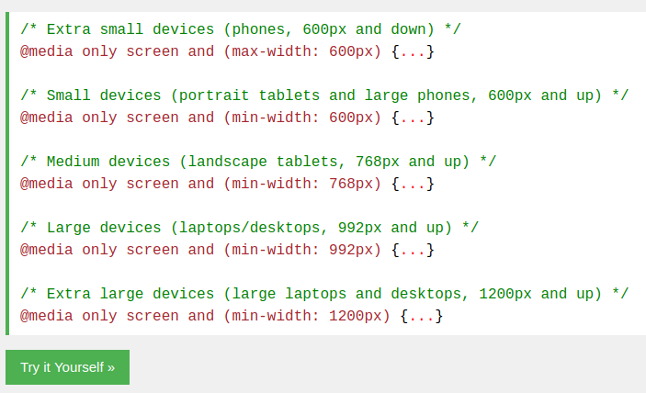

[**https://www.w3schools.com/css/css_rwd_mediaqueries.asp**](https://www.w3schools.com/css/css_rwd_mediaqueries.asp)

**export import js**

1. do this for source and destination

delete this



add this



2.

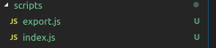

3.

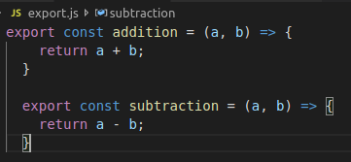

4.

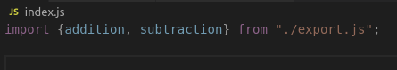

**mocha test with node.js**

1- the video : 2019-01-09 Test_Setup_mohammed_whflv

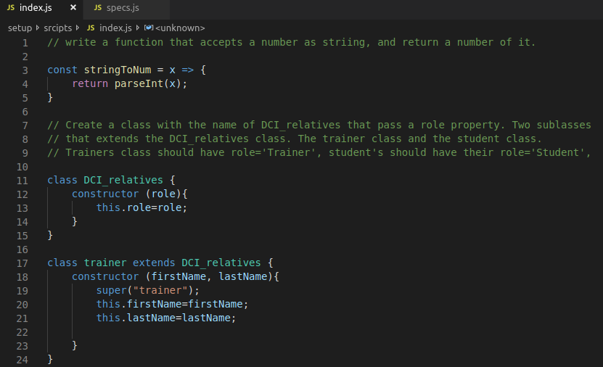

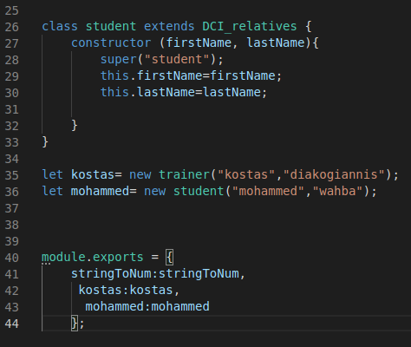

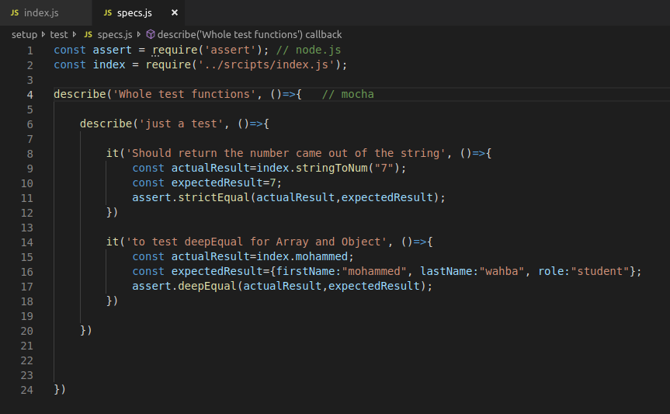

**react**

commands in terminal :

npm install --save react

npm install --save react-dom

npm install --save-dev @babel/preset-react

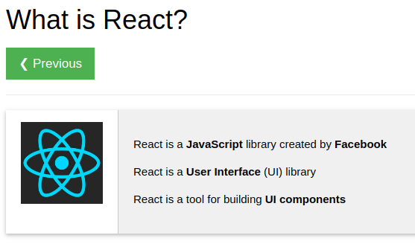

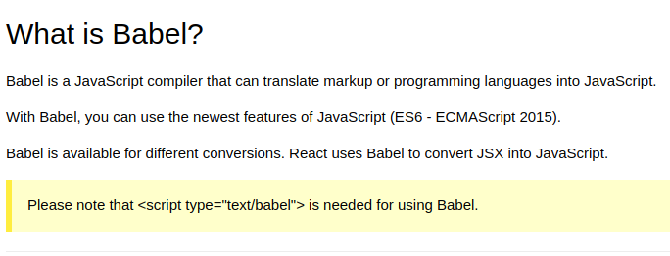

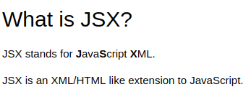

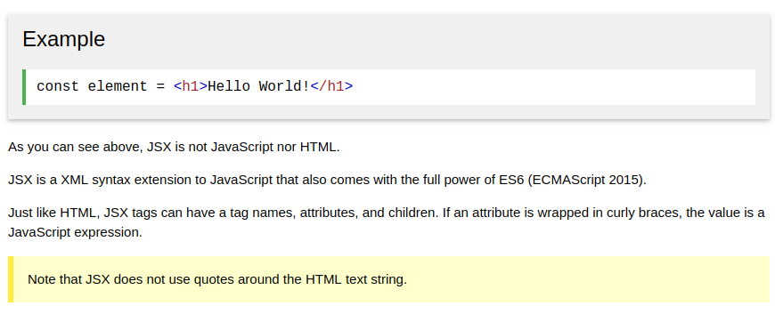

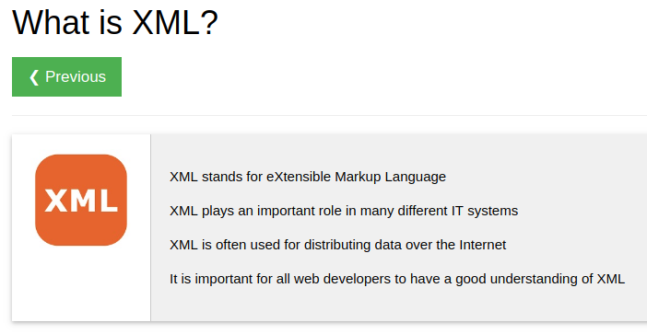XML is before  JSON

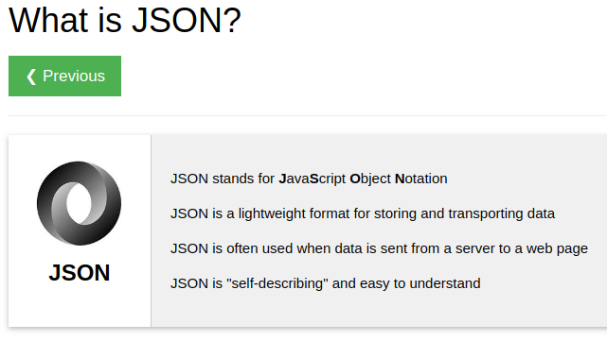

let come back to react:

**Routing**

**https://itnext.io/the-easiest-tutorial-on-react-router-v4-youll-ever-find-build-a-single-page-application-in-44c453f4123b**

SPA : Single page Application

MPA ; Multi Page Application

**----------------------------------------------------------------------------------------------------------------**

**JavaScript Array**find()**Method**



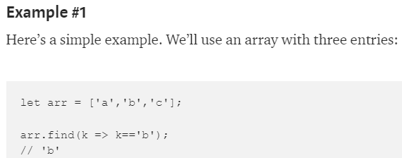

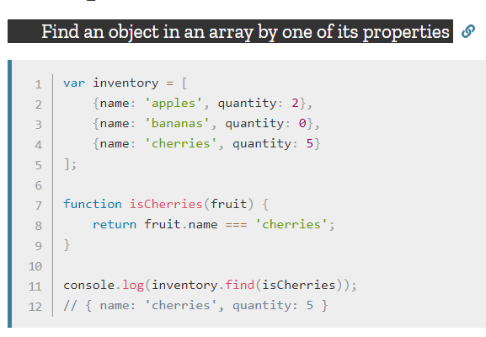

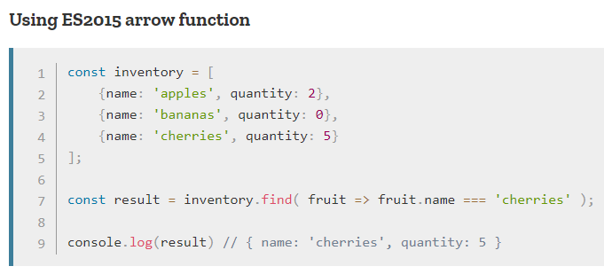

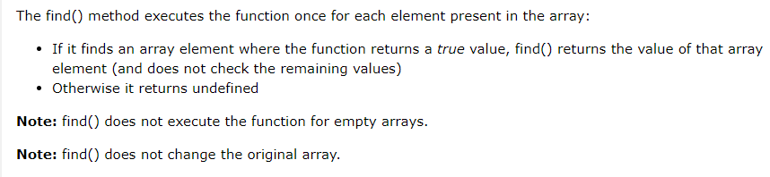

# -------------------------------------------------------------------------------------------------------

# JavaScript Array findIndex()

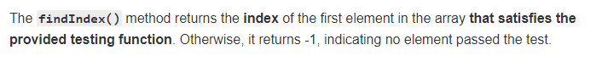

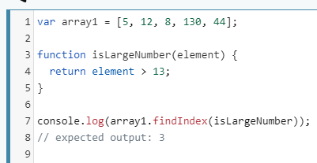

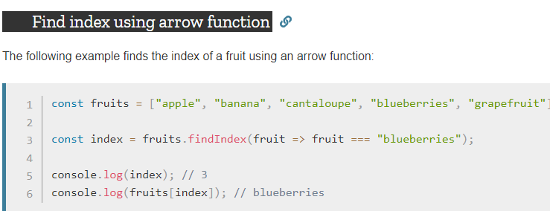

# JavaScript Array map() Method

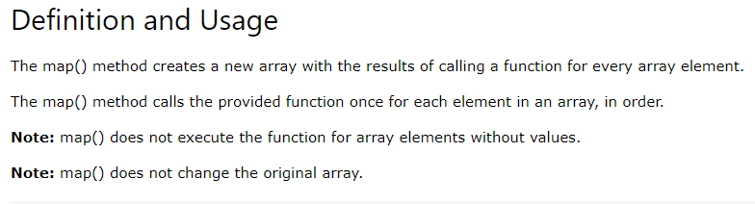

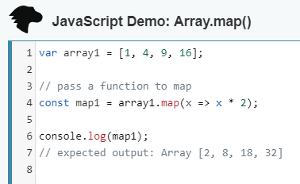

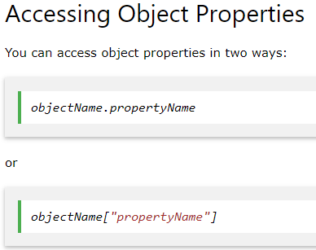

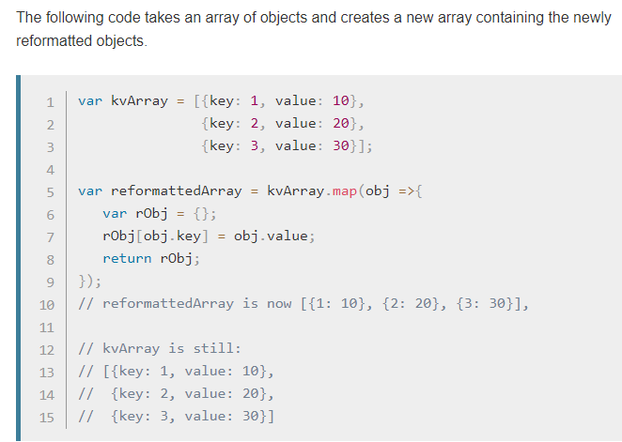

# JavaScript Array forEach()

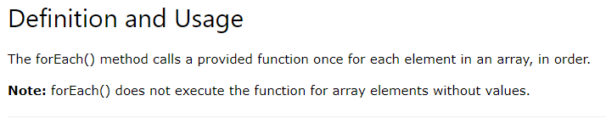

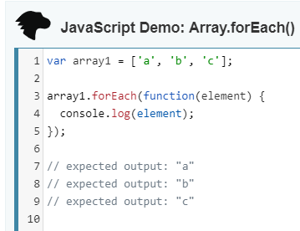

* forEach() doesn't change the original array.

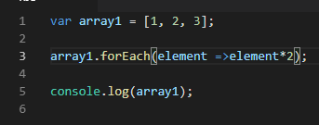

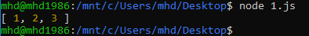

**JavaScript Array**reduce()

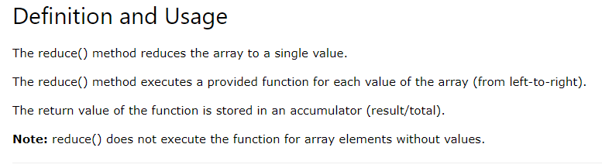

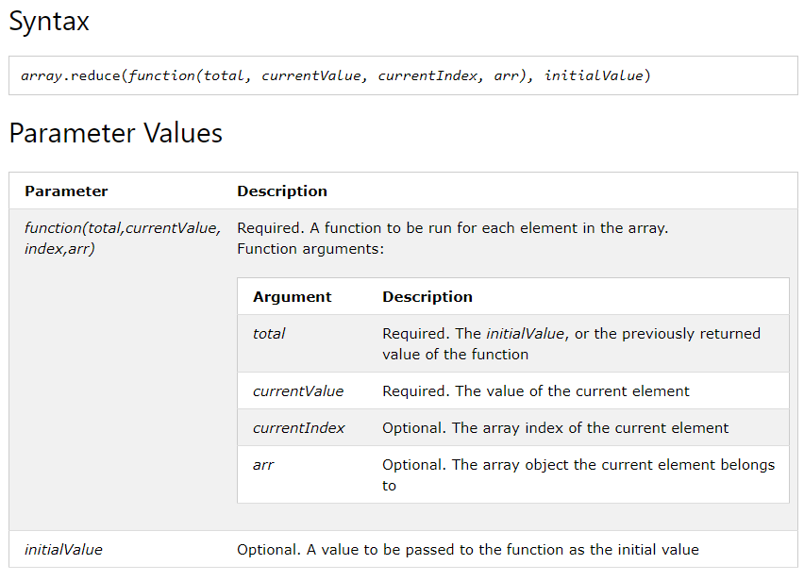

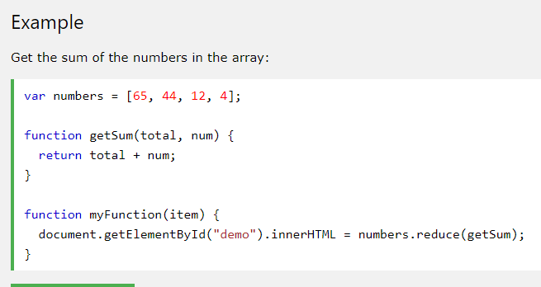

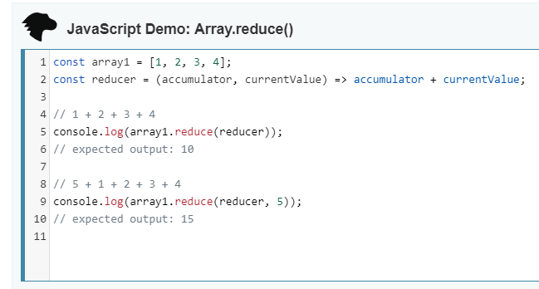

**css Example**

Css Example

**css Example**

Css Example



https://www.w3schools.com/js/js_arithmetic.asp